

**Project Report**

**Online Railway Reservation System**

Submitted to:

**Dr. Khaldoon Khurshid**

Submitted by:

**Ali Adnan Aslam (2015-CS-17)**

**Muhammad Ramzan (2015-CS-54)**

**Malik M. Mursaleen (2015-CS-64)**

**Department of Computer Science and Engineering**

**University of Engineering and Technology, Lahore.**

Table of Contents

*Online railway reservation system* 3

Introduction: 3

• **Prioritizing a user** 3

• **Complain facility** 3

• **Payment method** 3

Week 1: 4

**Slides** 4

**Notebook** 20

**Chart of week 1** 36

Week 2: 37

**Slides** 37

**Notebook** 50

**Chart of Week 2** 53

Week 3: 54

**Slides** 54

**Notebook** 62

**Chart of Week 3** 68

DBMS Prototype Code: 69

**AdminUser Model Code** 69

**AdminUser Controller Code** 70

**AdminUser Views Code** 72

• **Create AdminUser** 72

• **Read AdminUser** 74

• **Update AdminUser** 76

• **Delete AdminUser** 78

Query Optimization……………………………………………………………………………………………………………………………….80

# 

# **Online railway reservation system**

# Introduction:

This system basically concerned with reservation and cancellation tickets to the passengers. The need of this system arose as Pakistan has large railway system.

Initially manual system was very problematic & resource consuming. A large number of employees, huge space for files and searching of specific record was not so easy. By the time mostly problems are being overcooked but still there are some issues in this system that should be resolved and that’s why in this system we came up with some innovations.

## **Prioritizing a user**

Student, Dept. Employee etc. according to their status

## **Complain facility**

Complain about maintenance, timing, staff

## **Payment method**

Transition using mobicash, easy paisa, Bank etc.

# Week 1:

## **Slides**

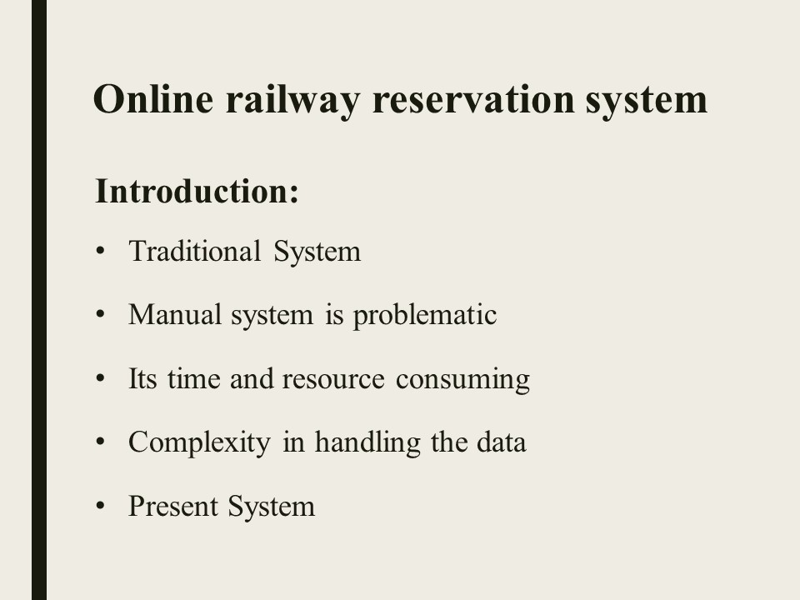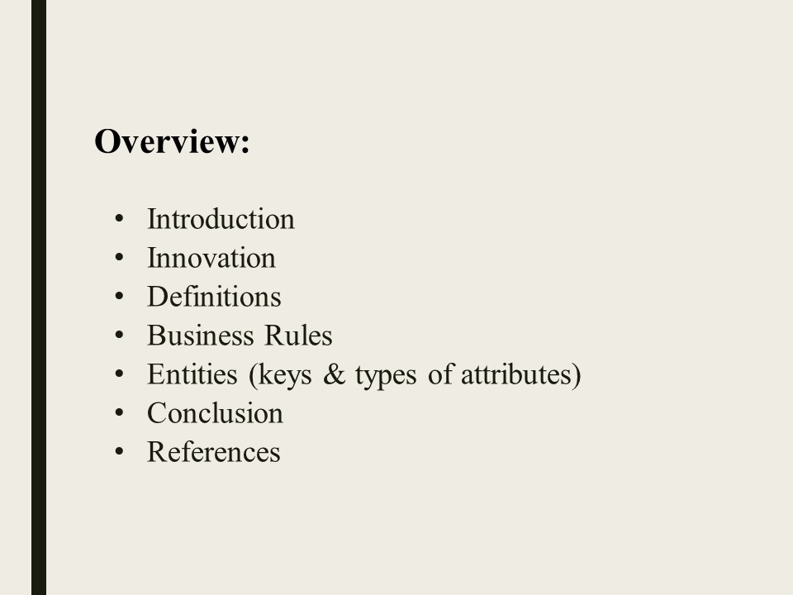

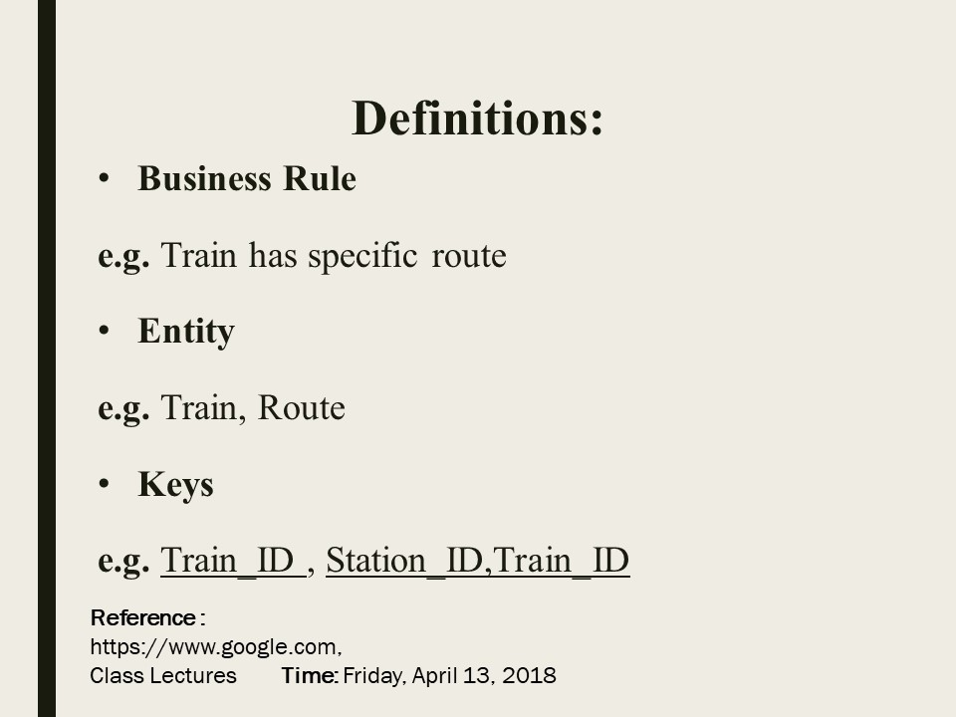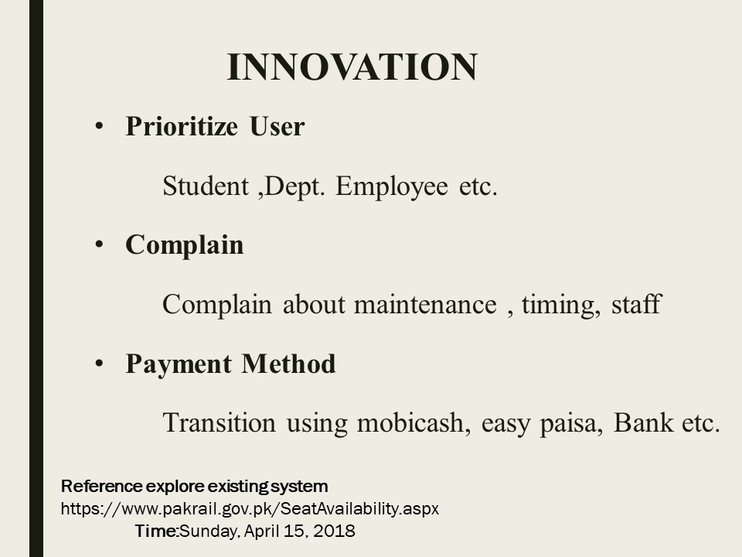

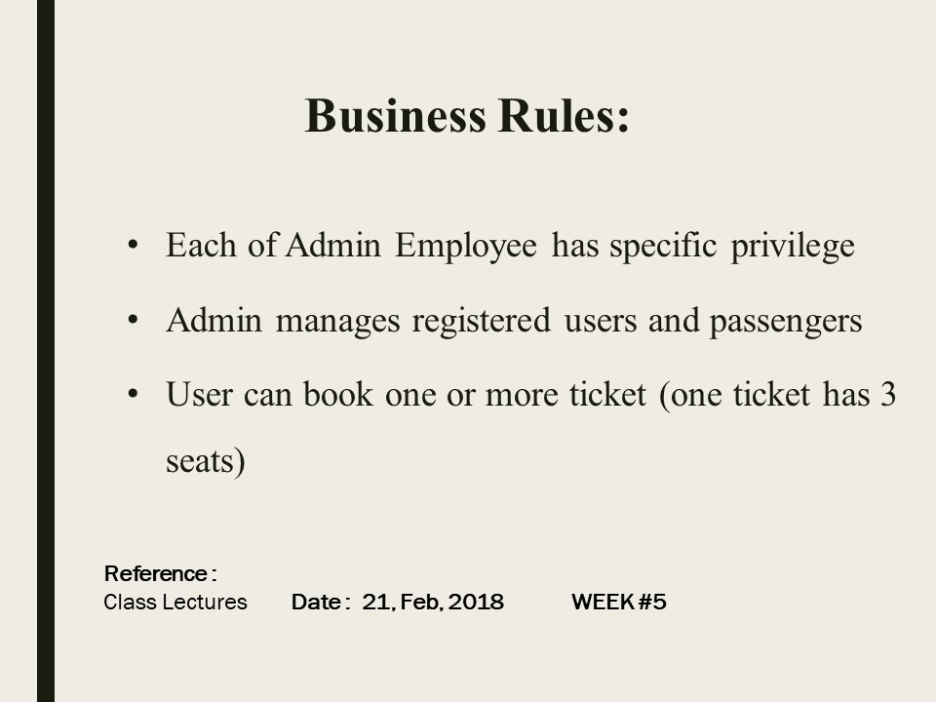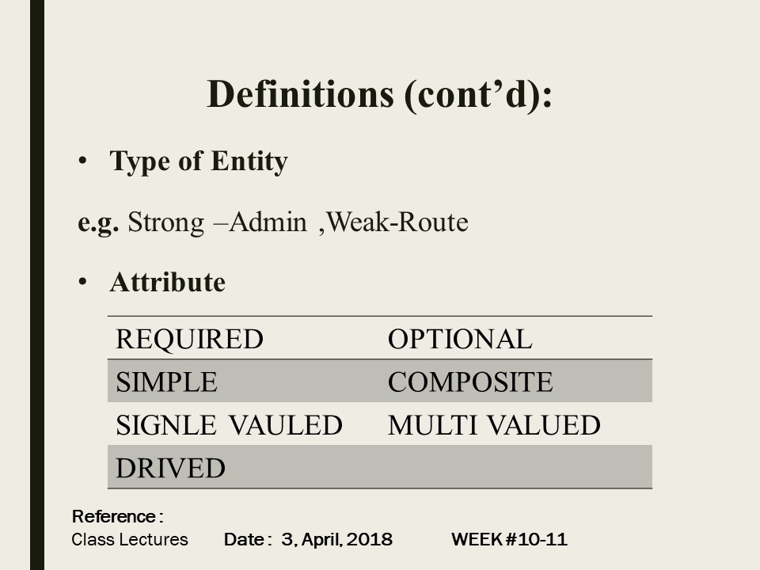

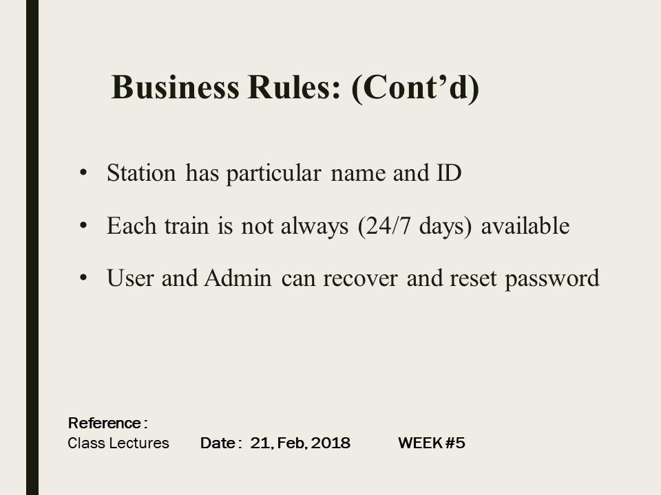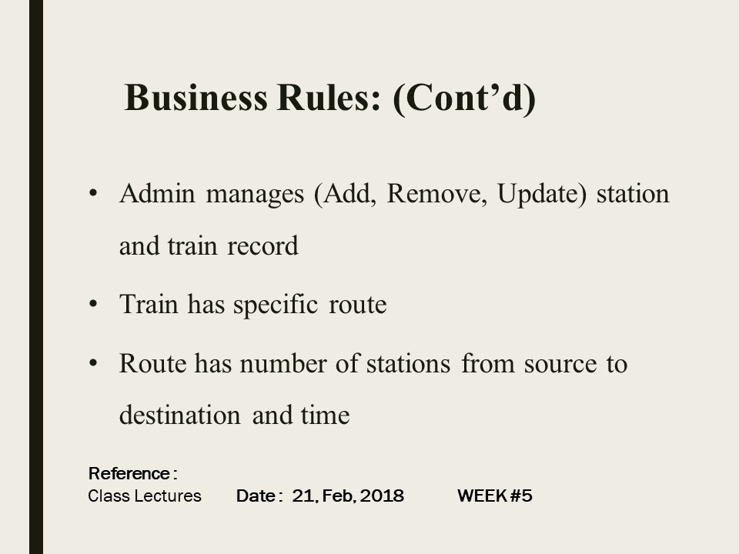

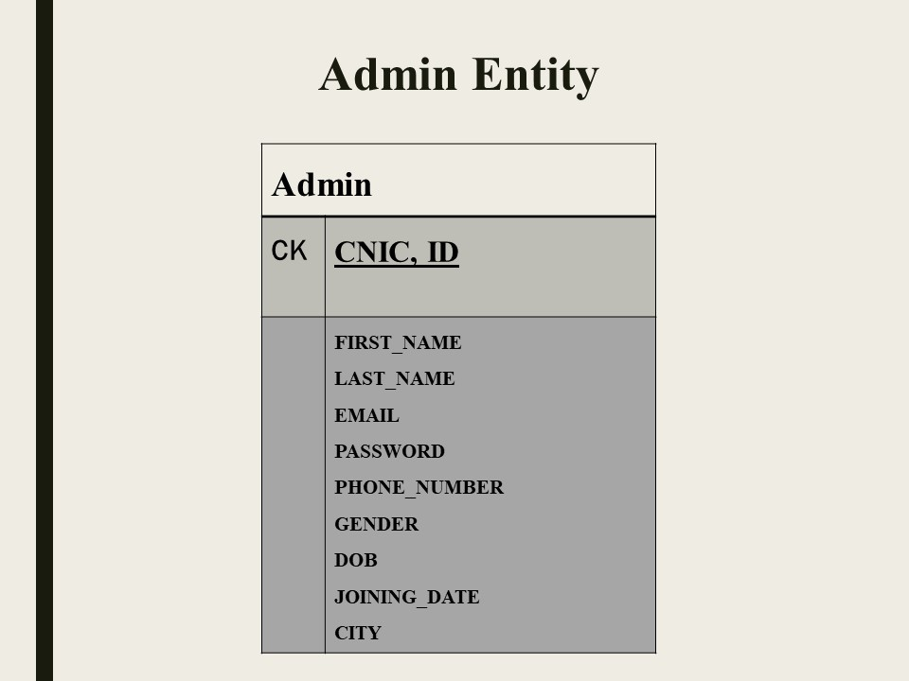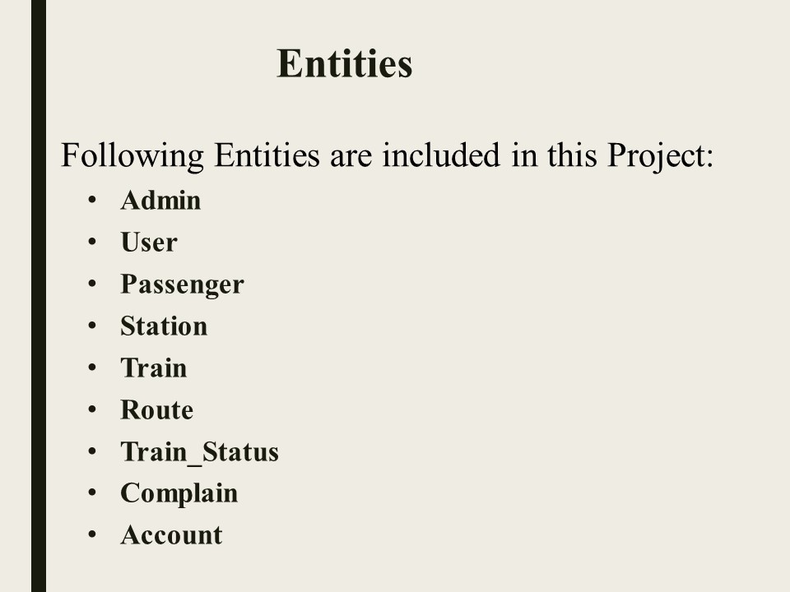

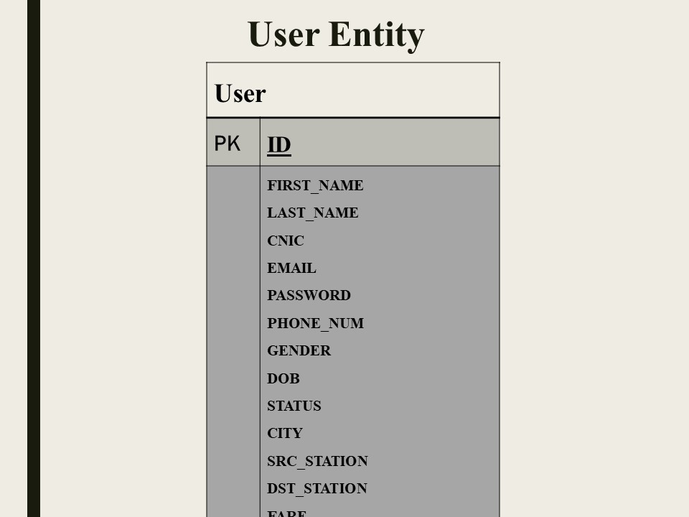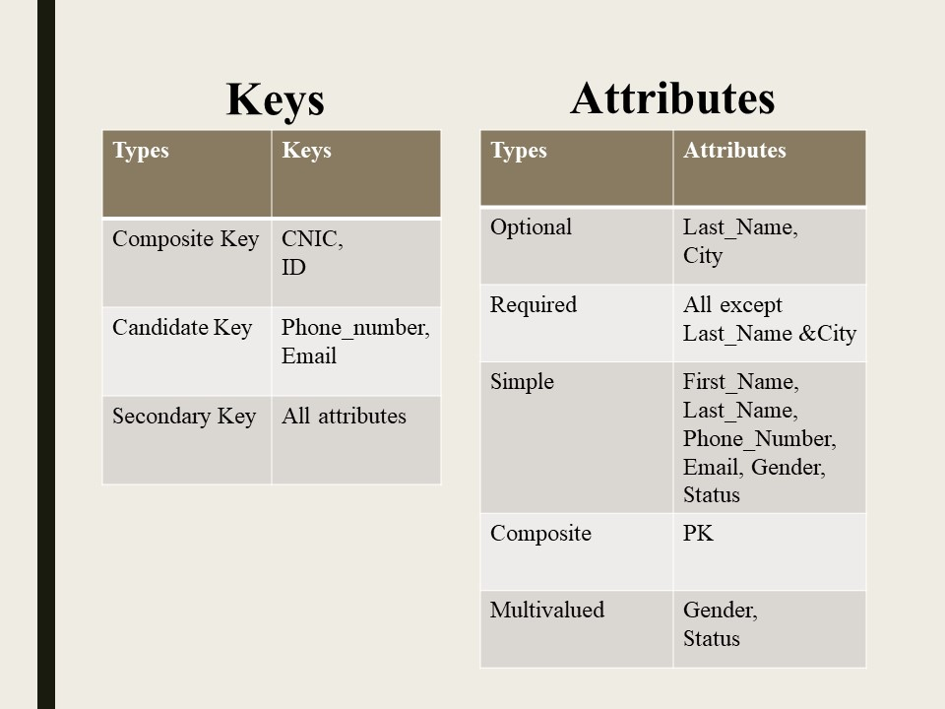

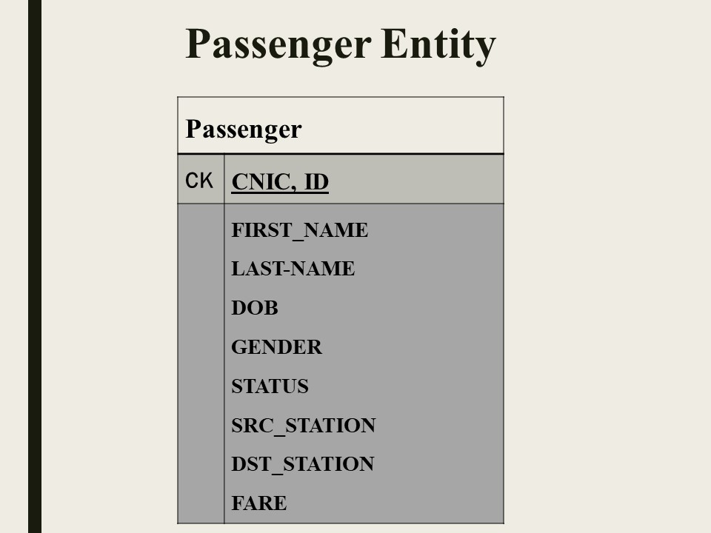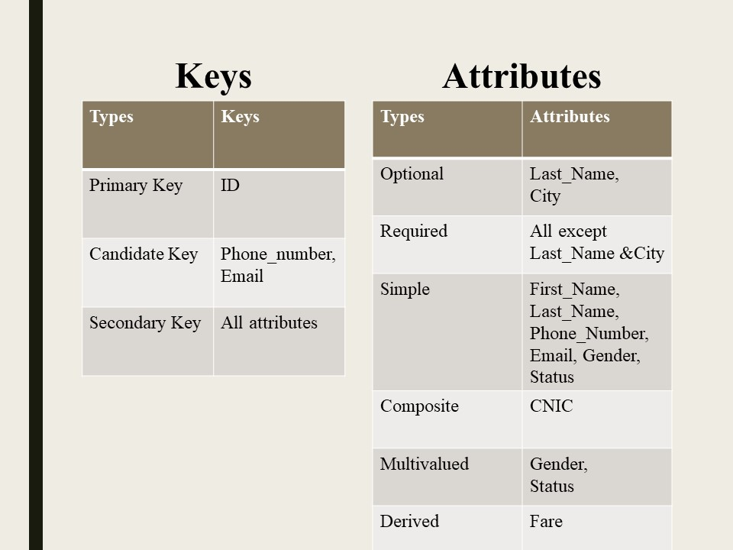

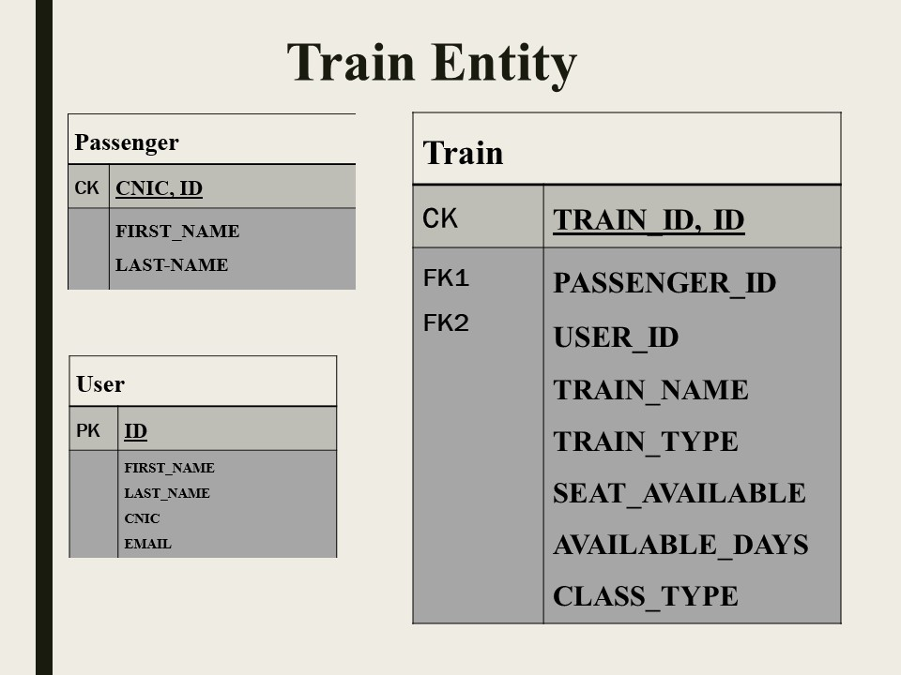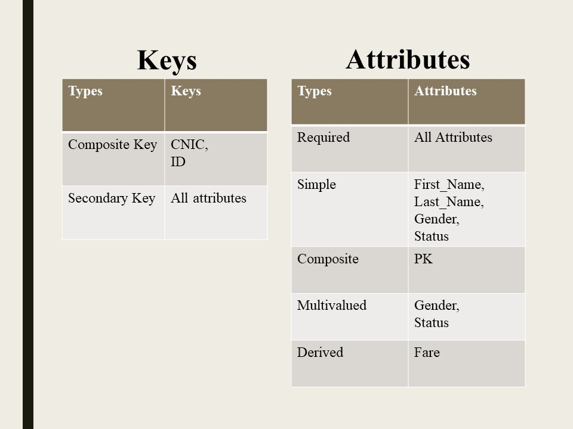

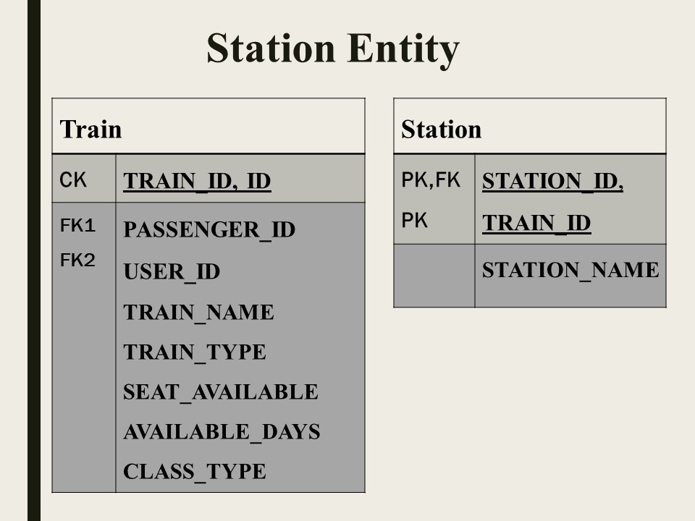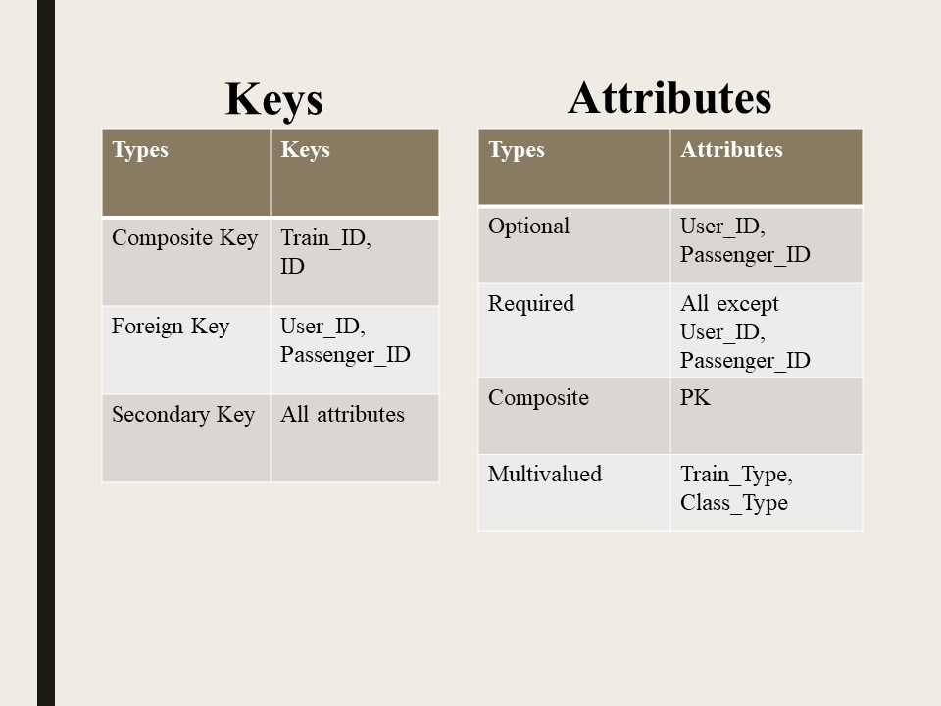

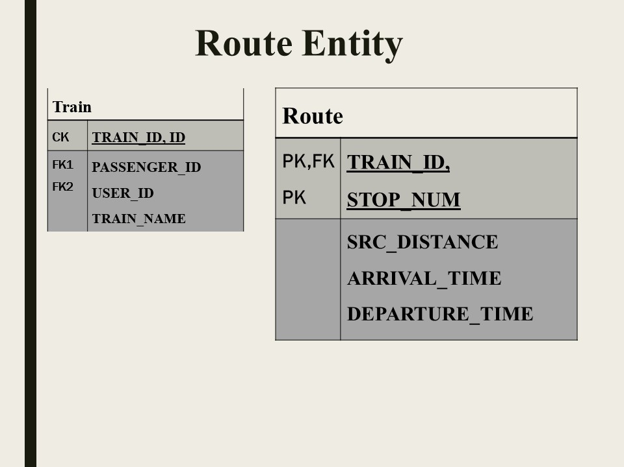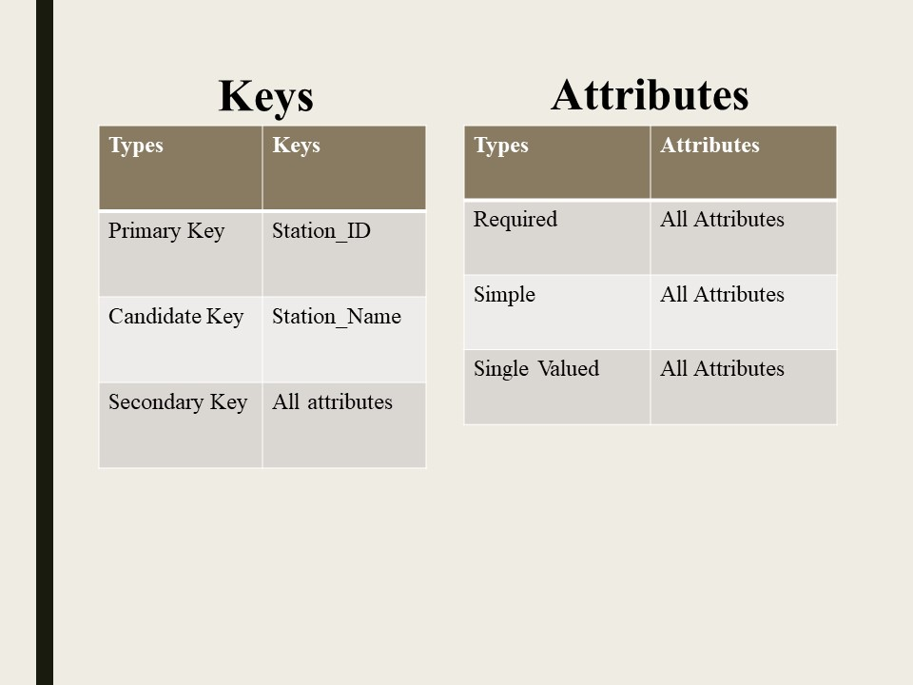

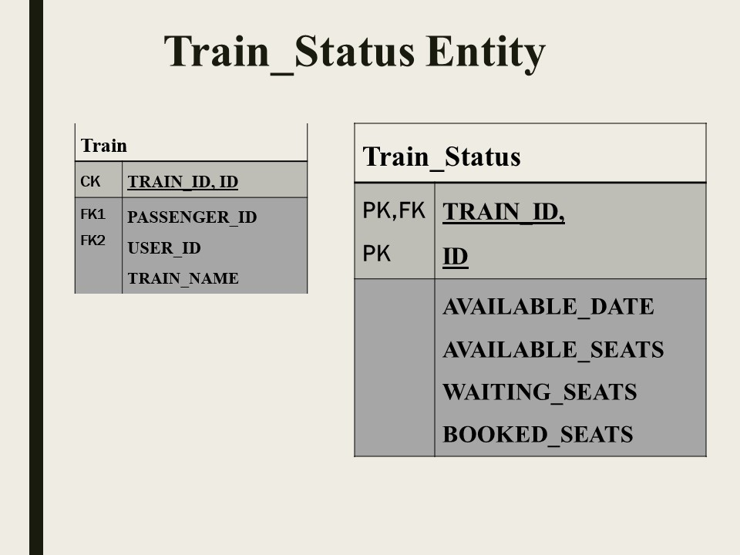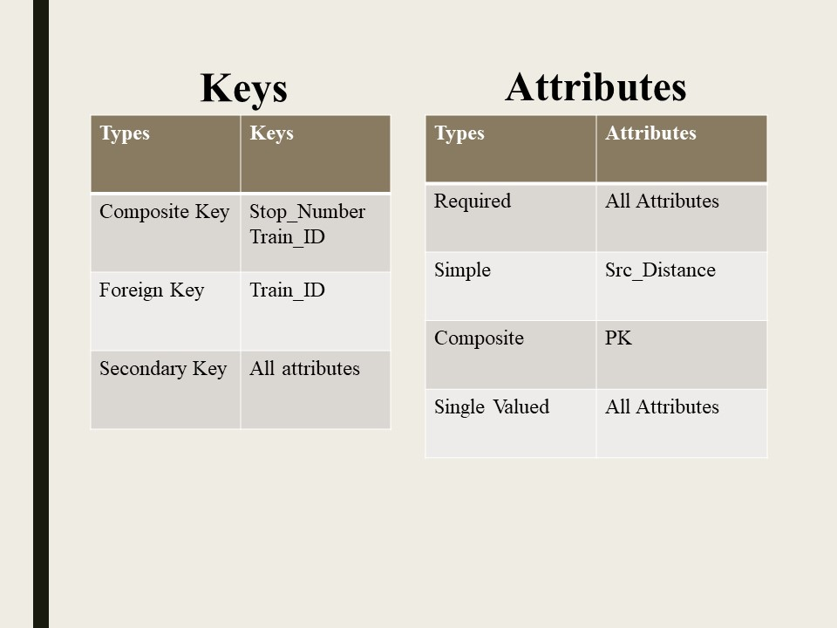

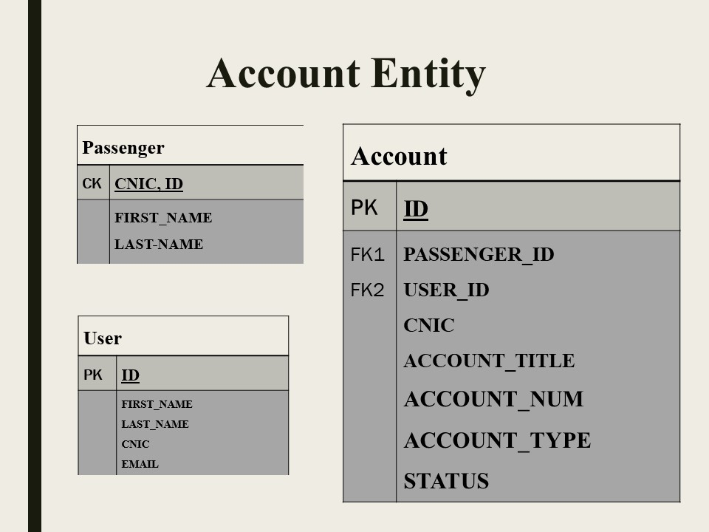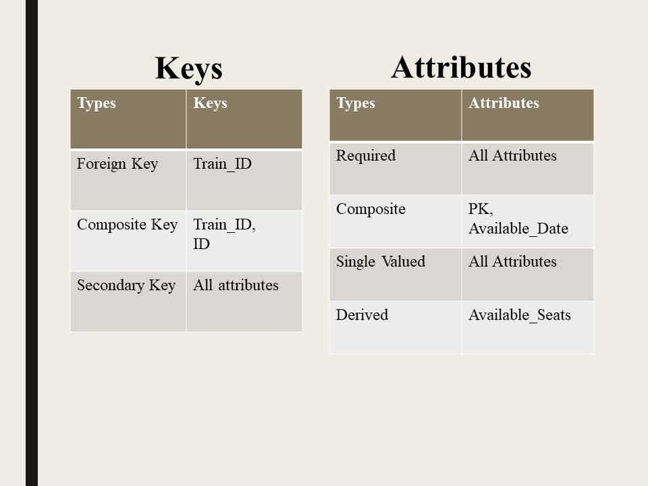

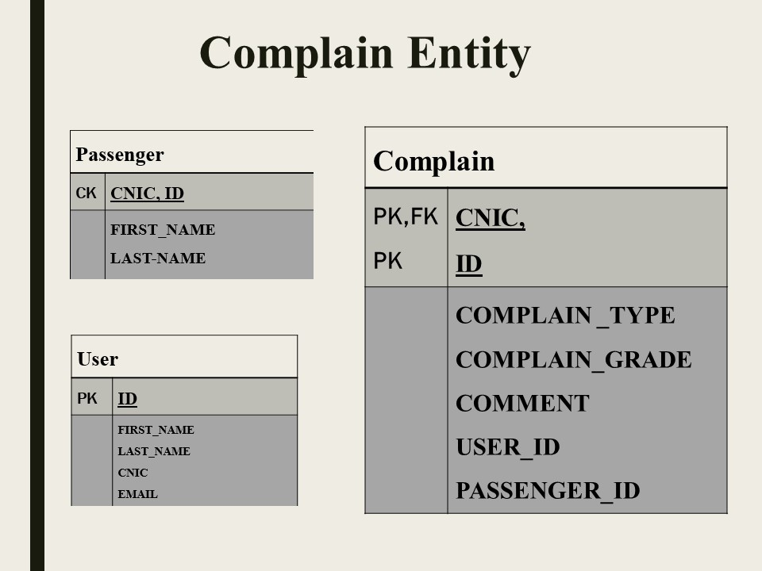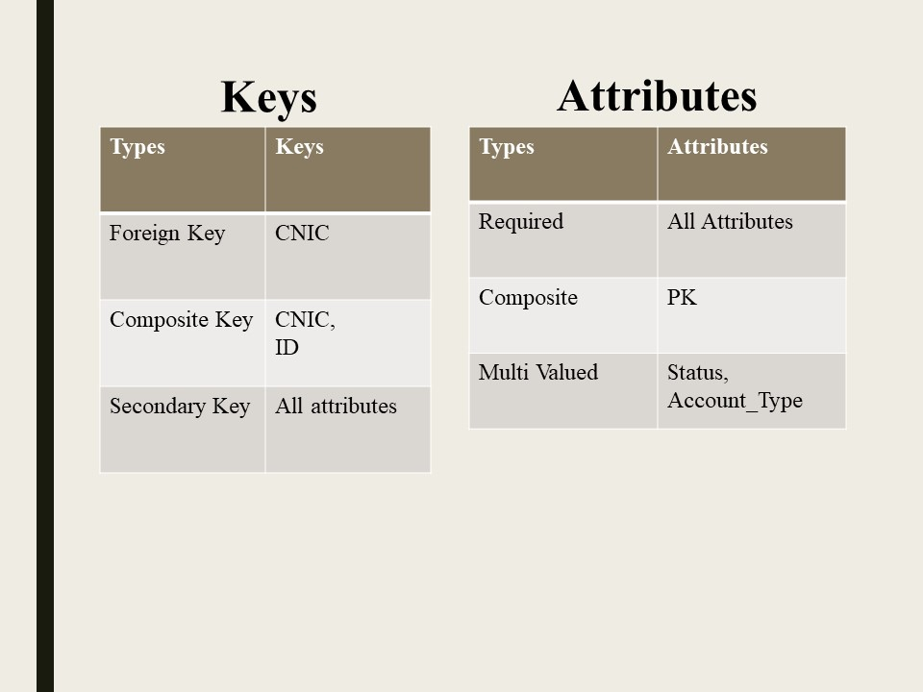

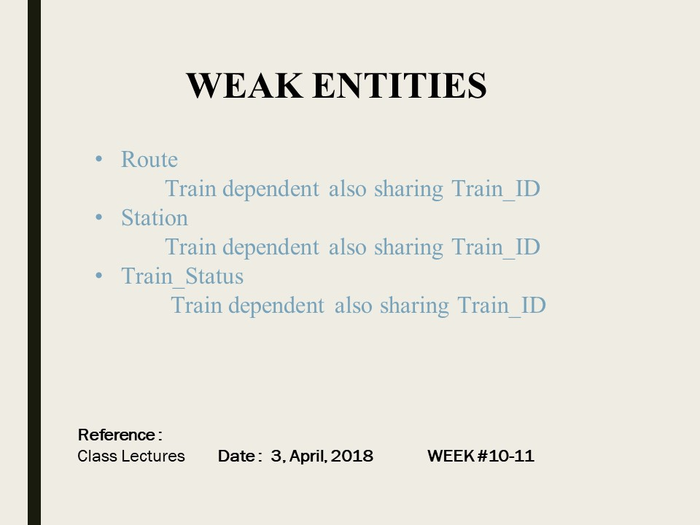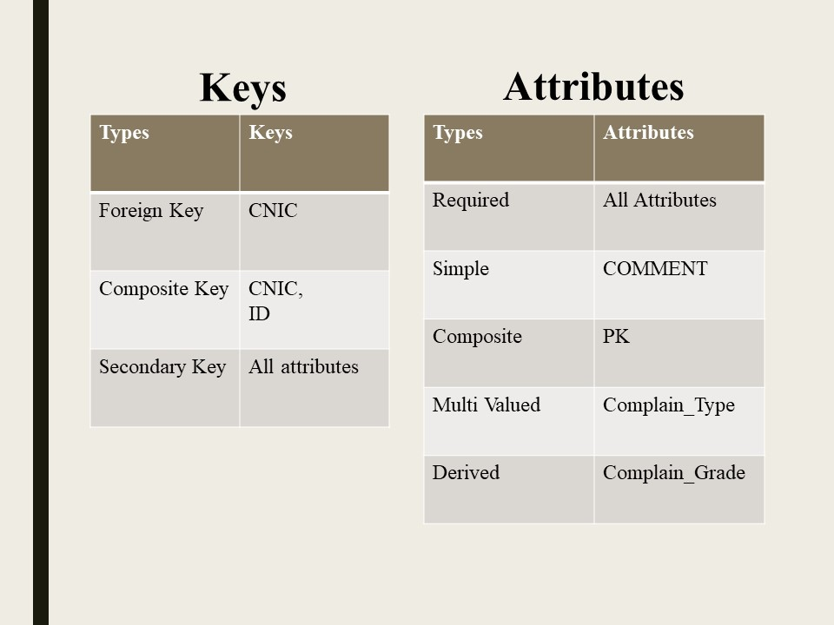

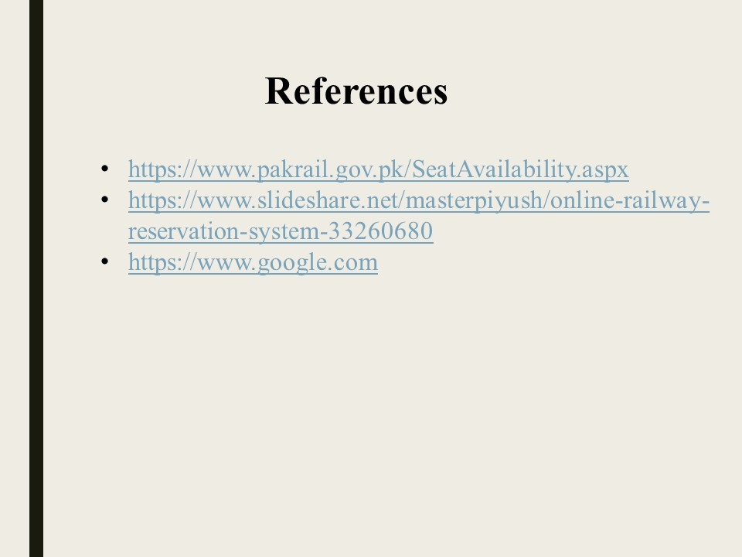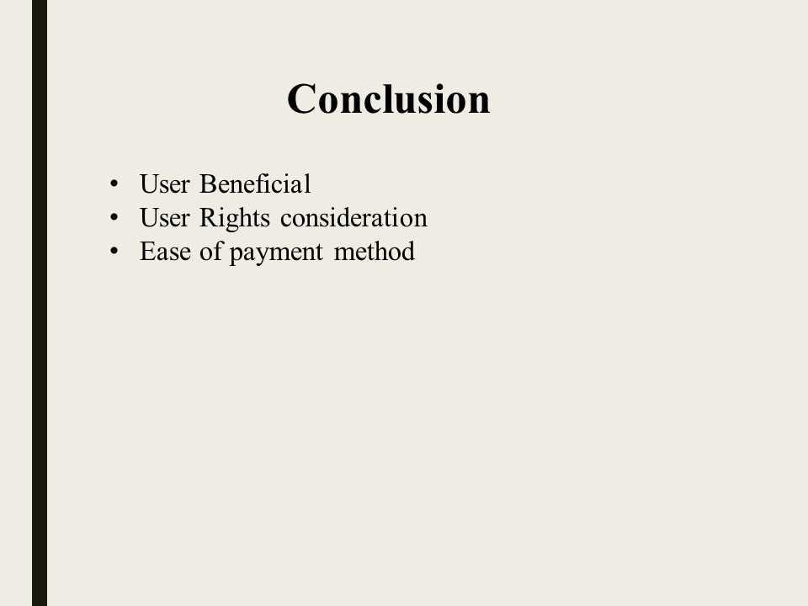

## **Notebook**

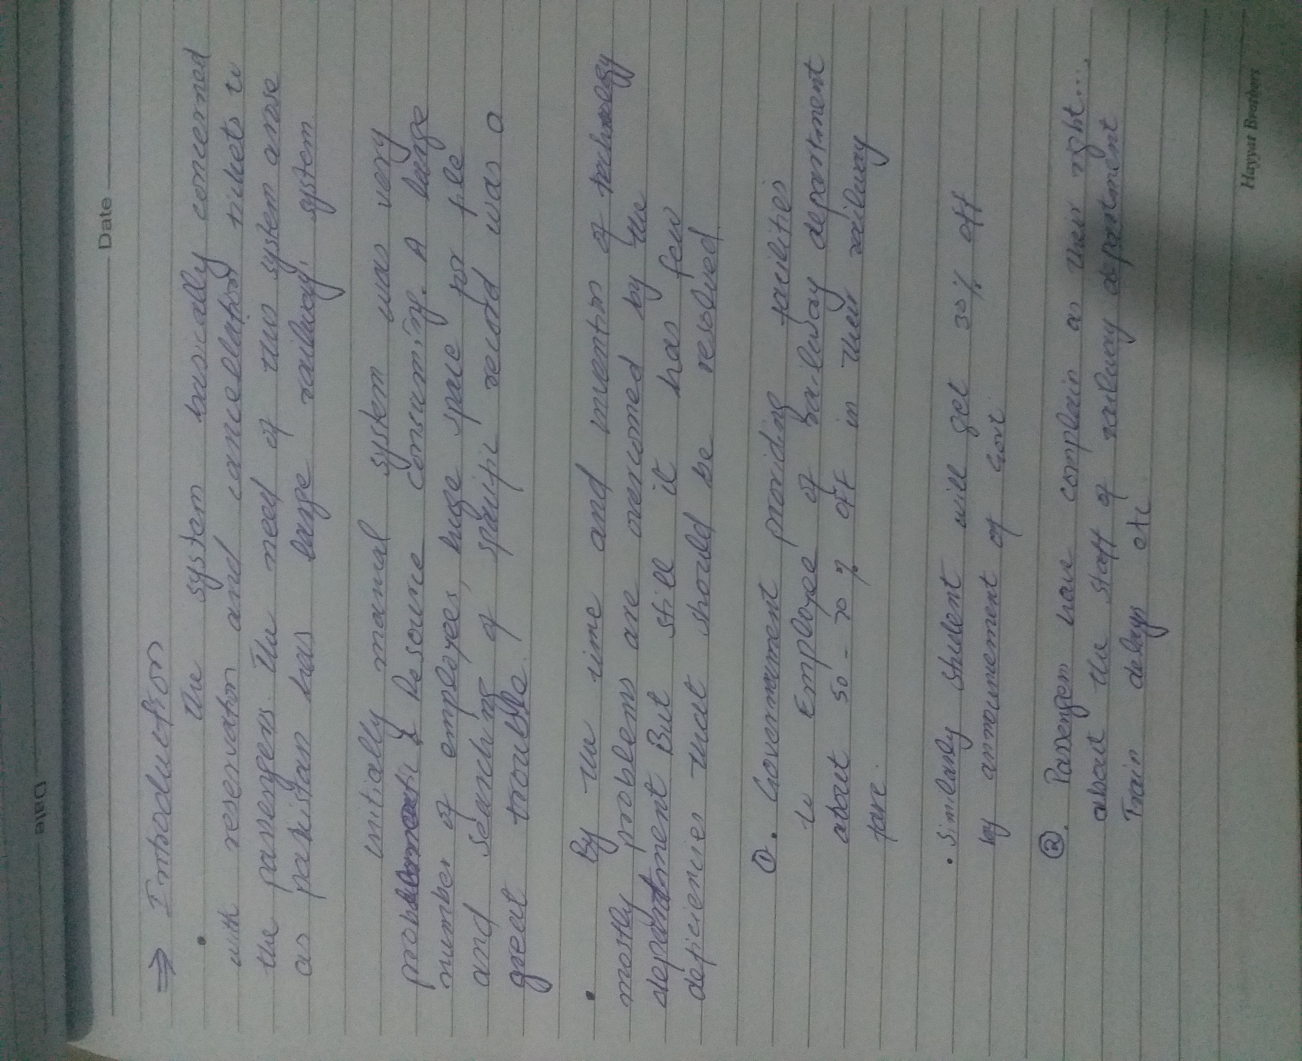

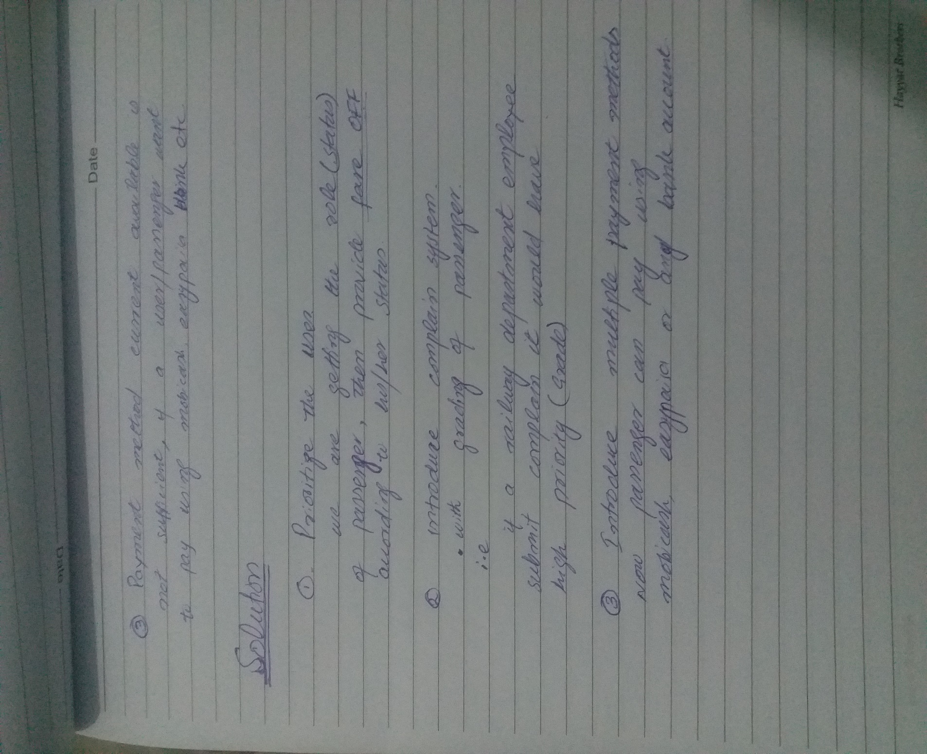

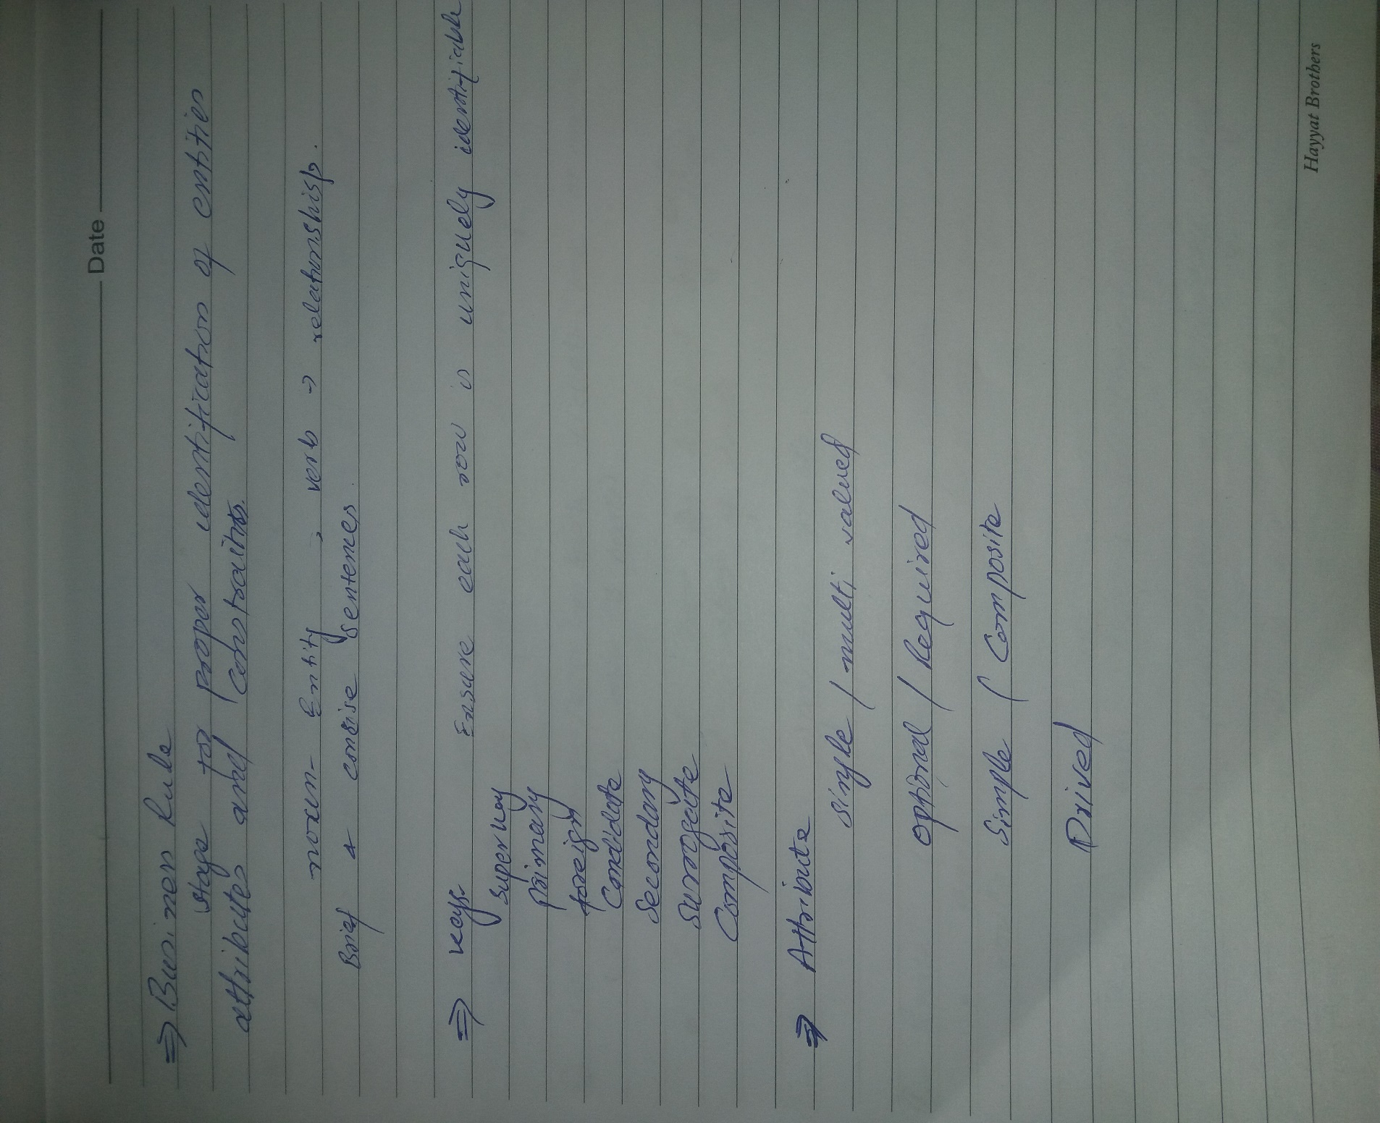

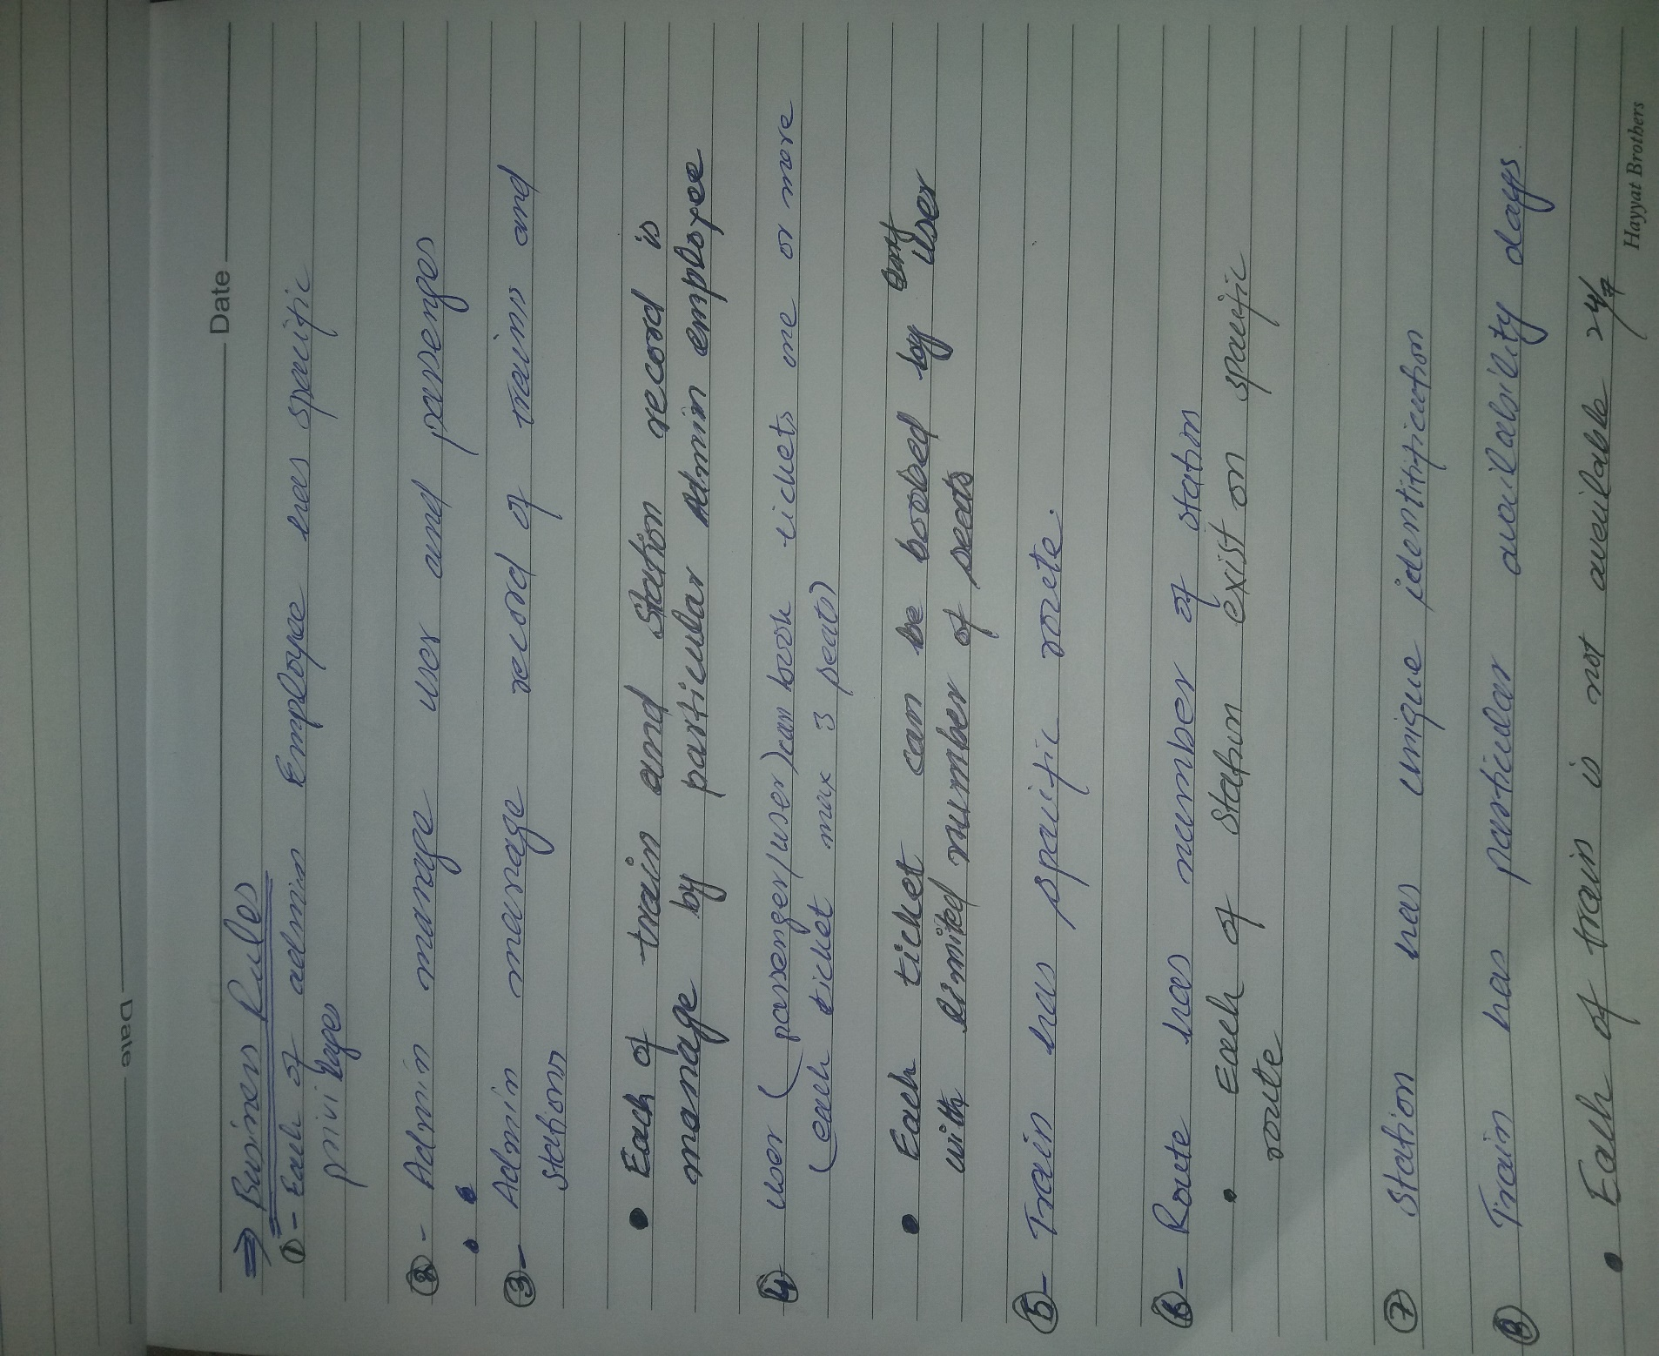

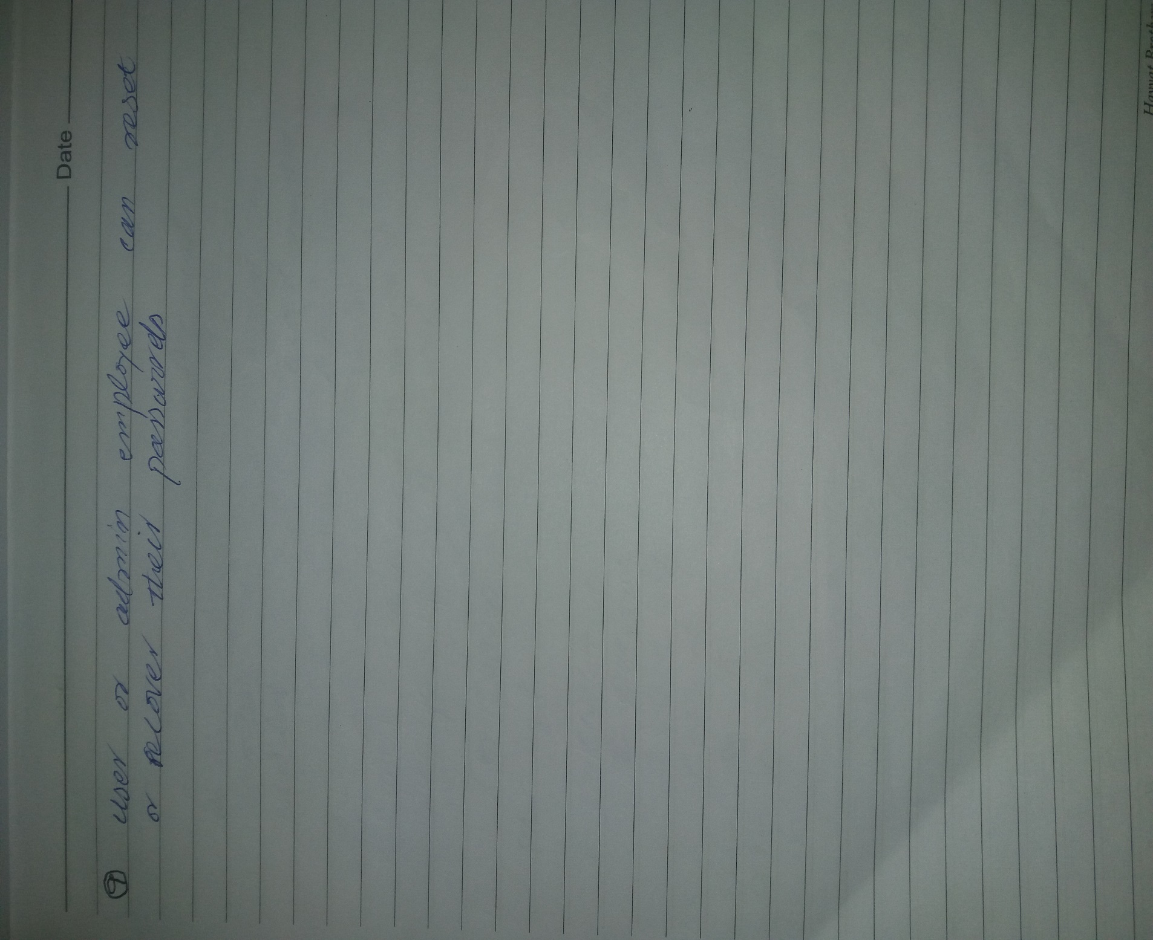

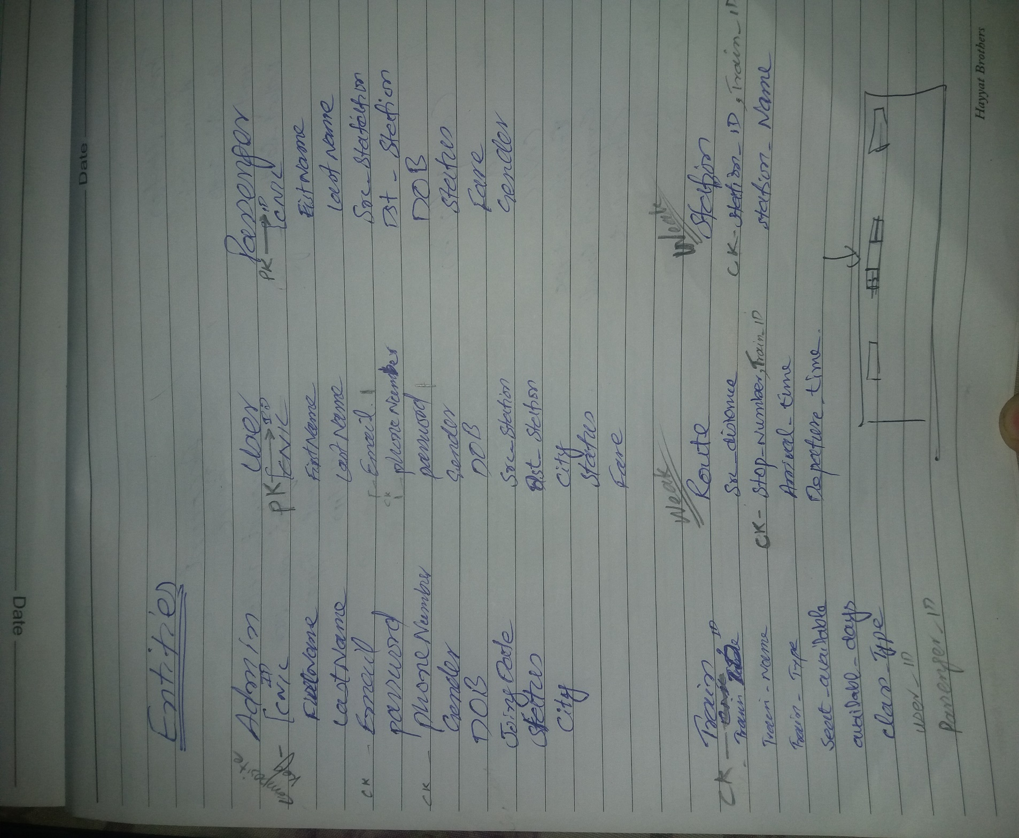 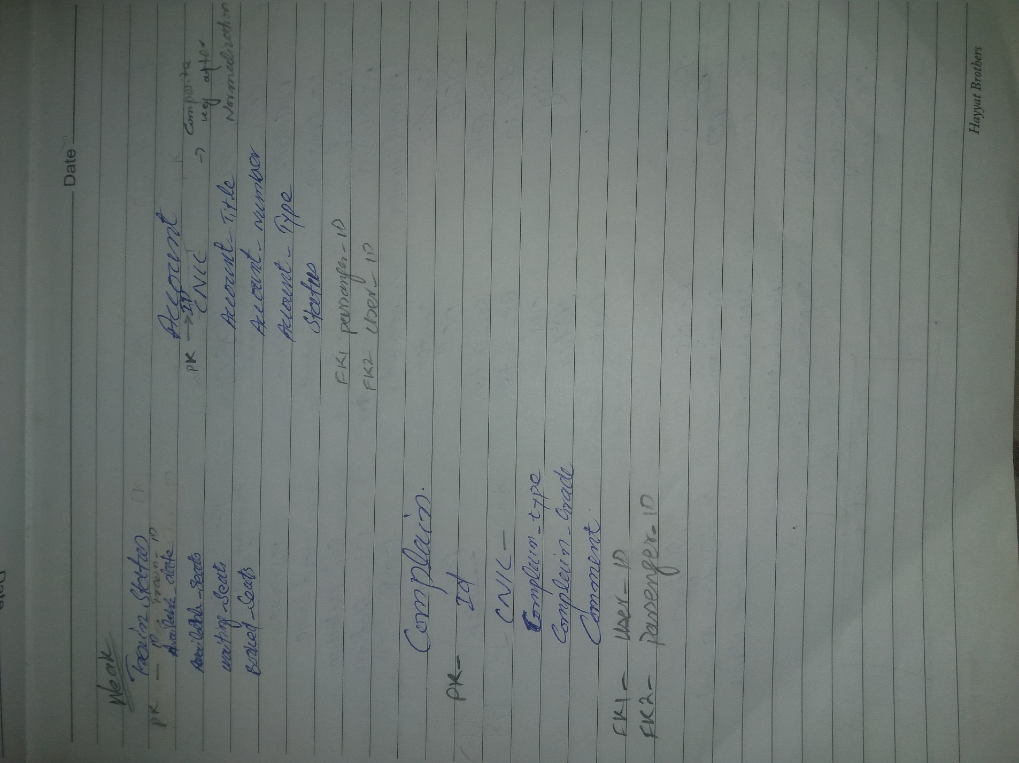 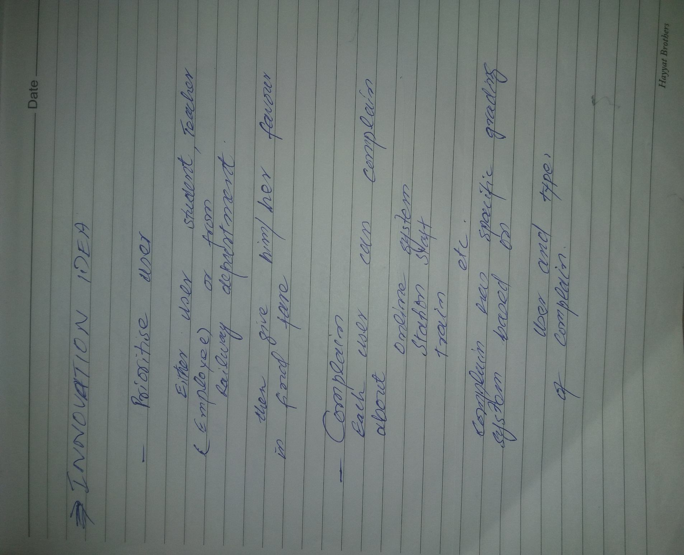

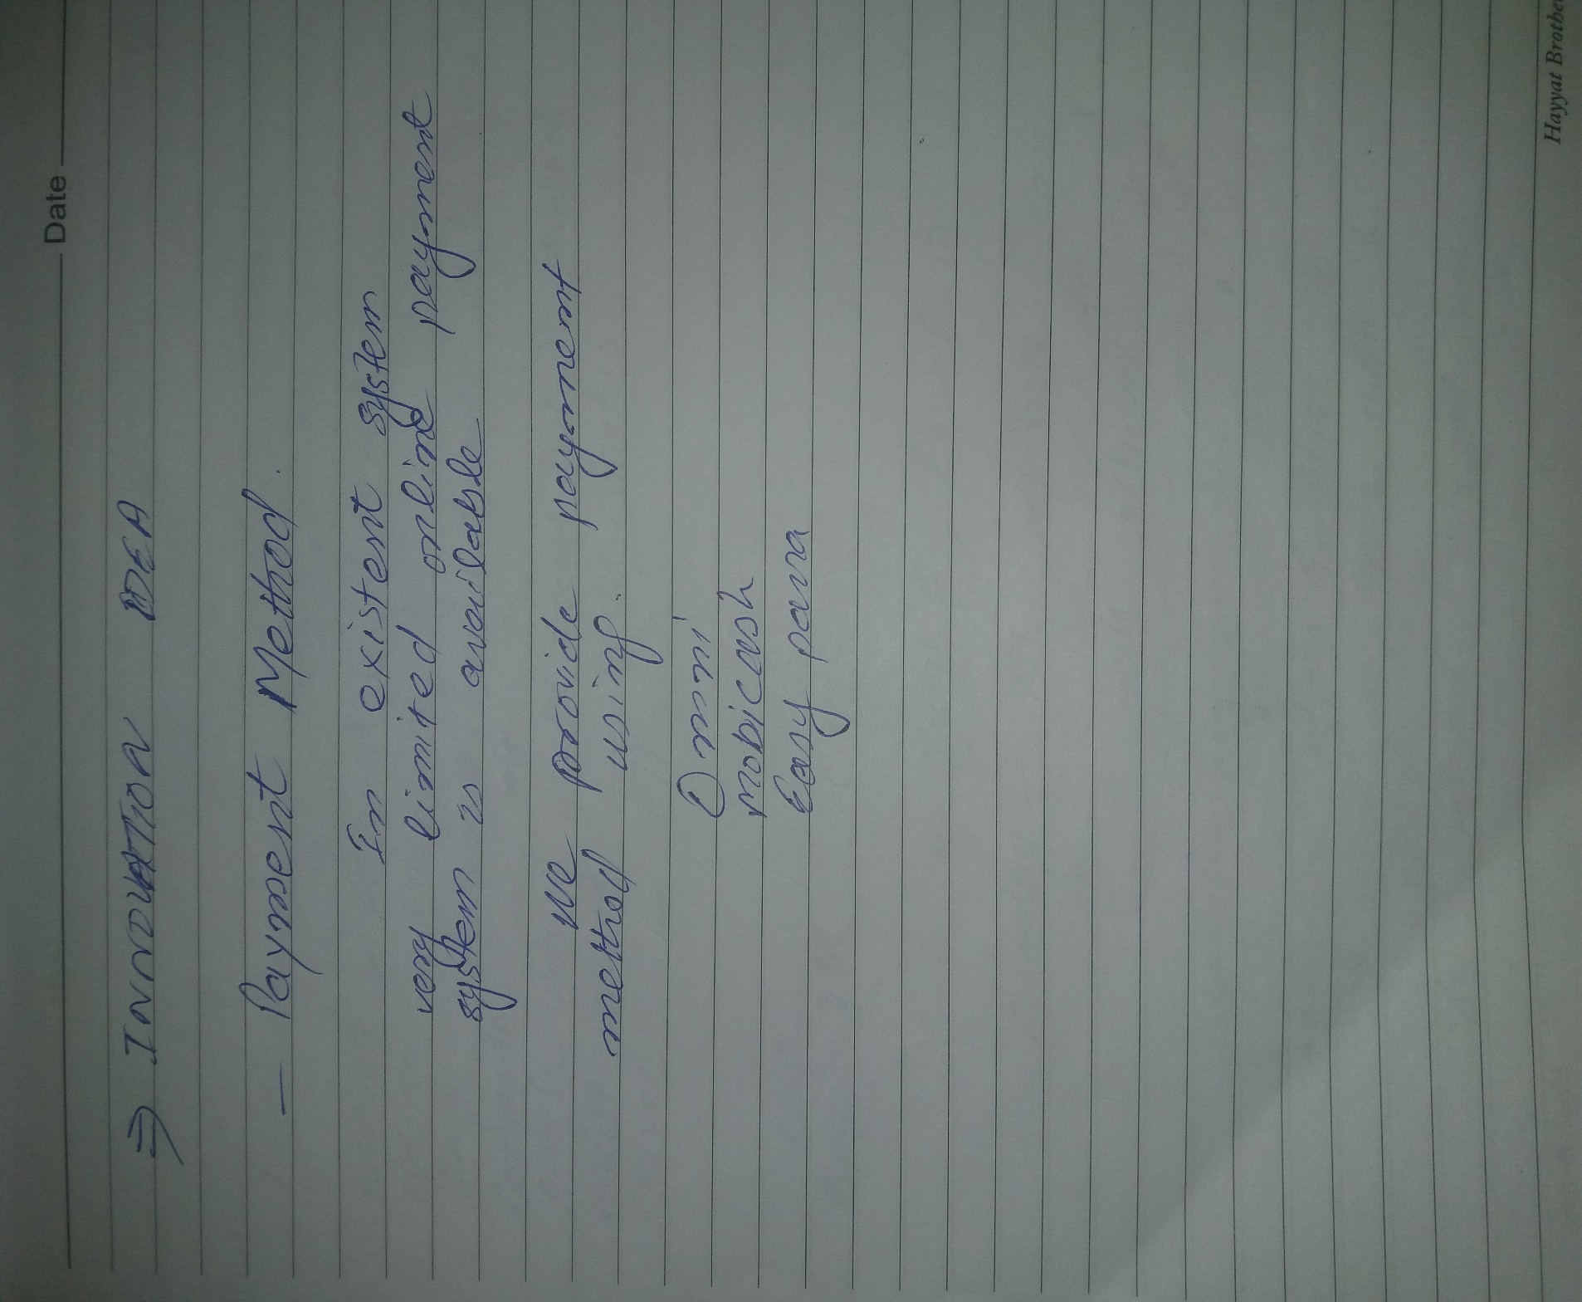

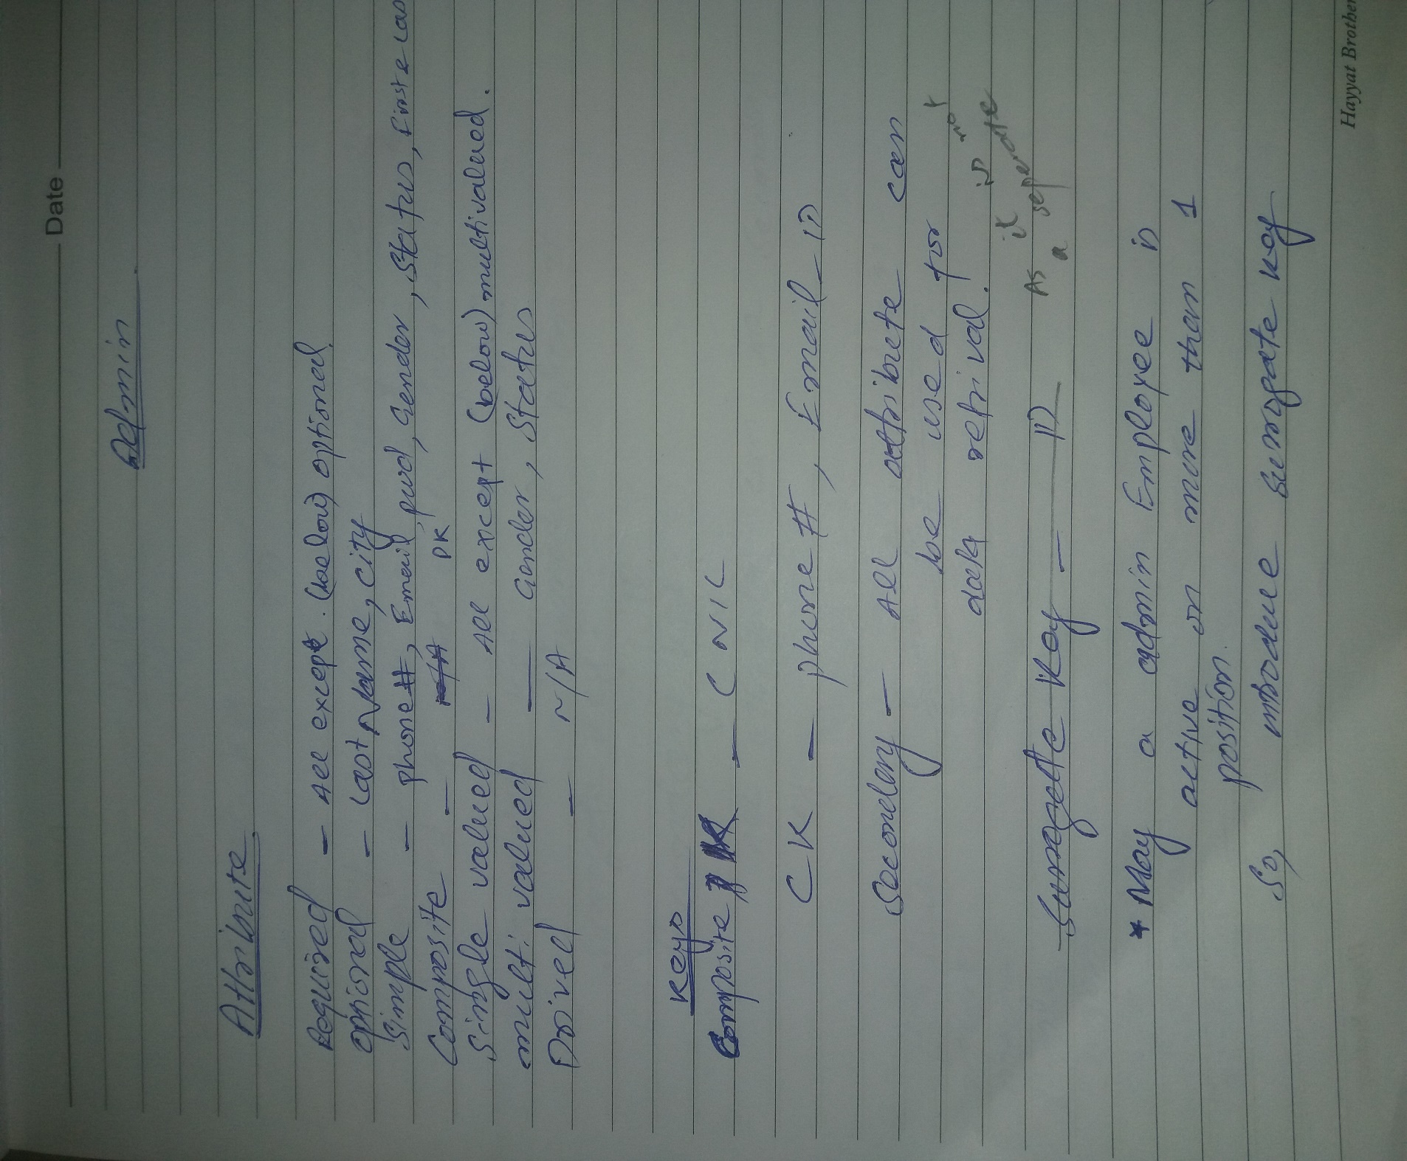

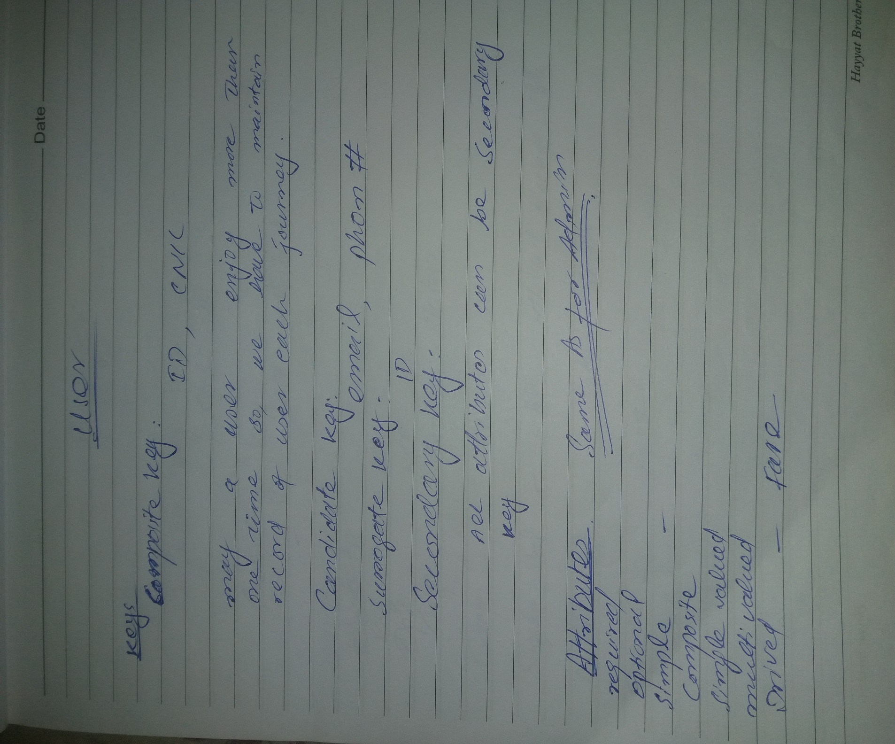

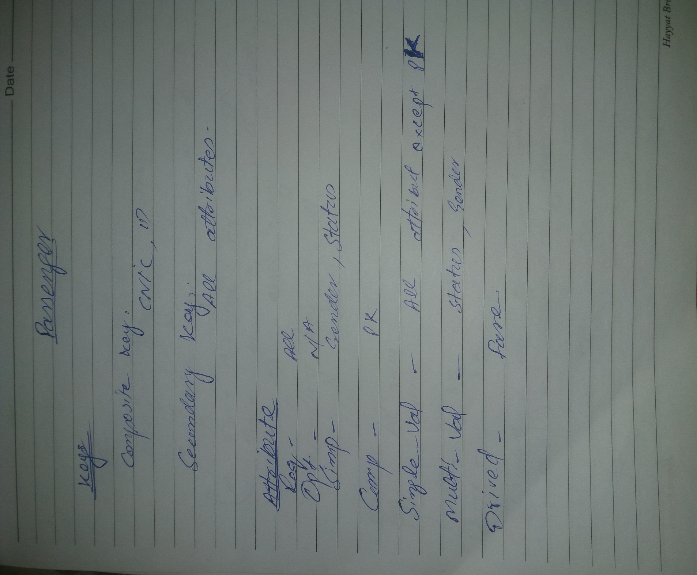

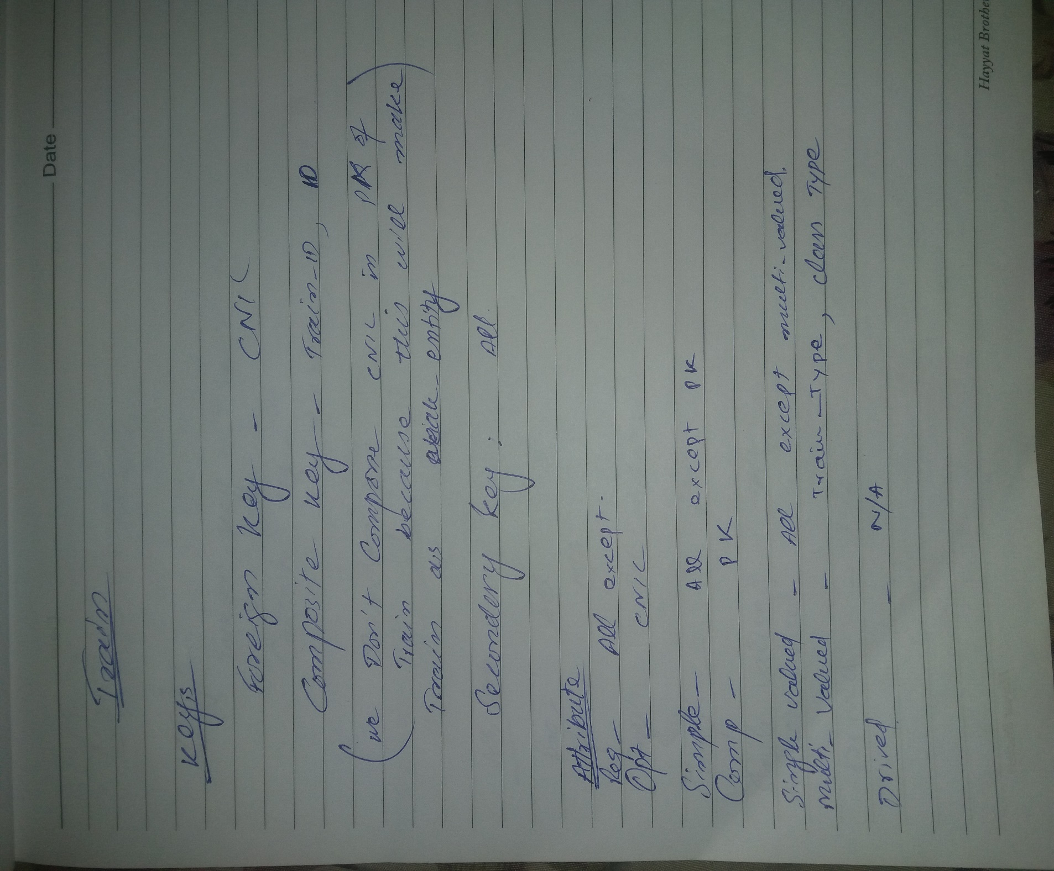

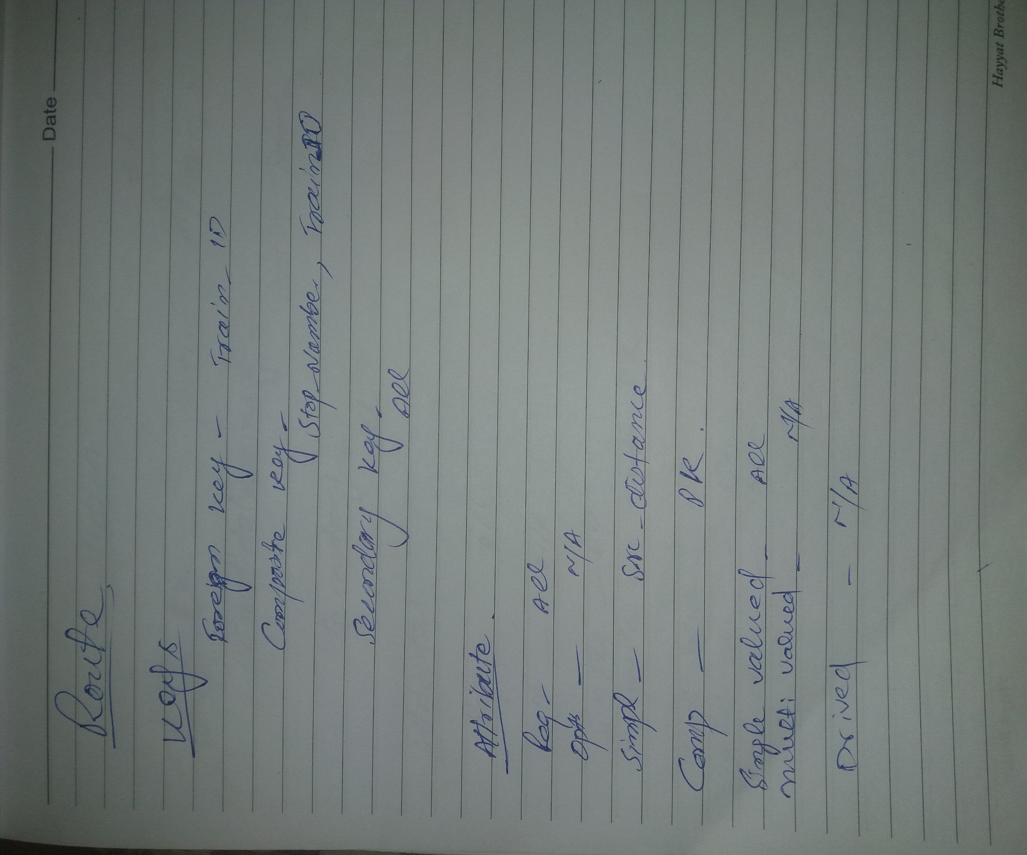

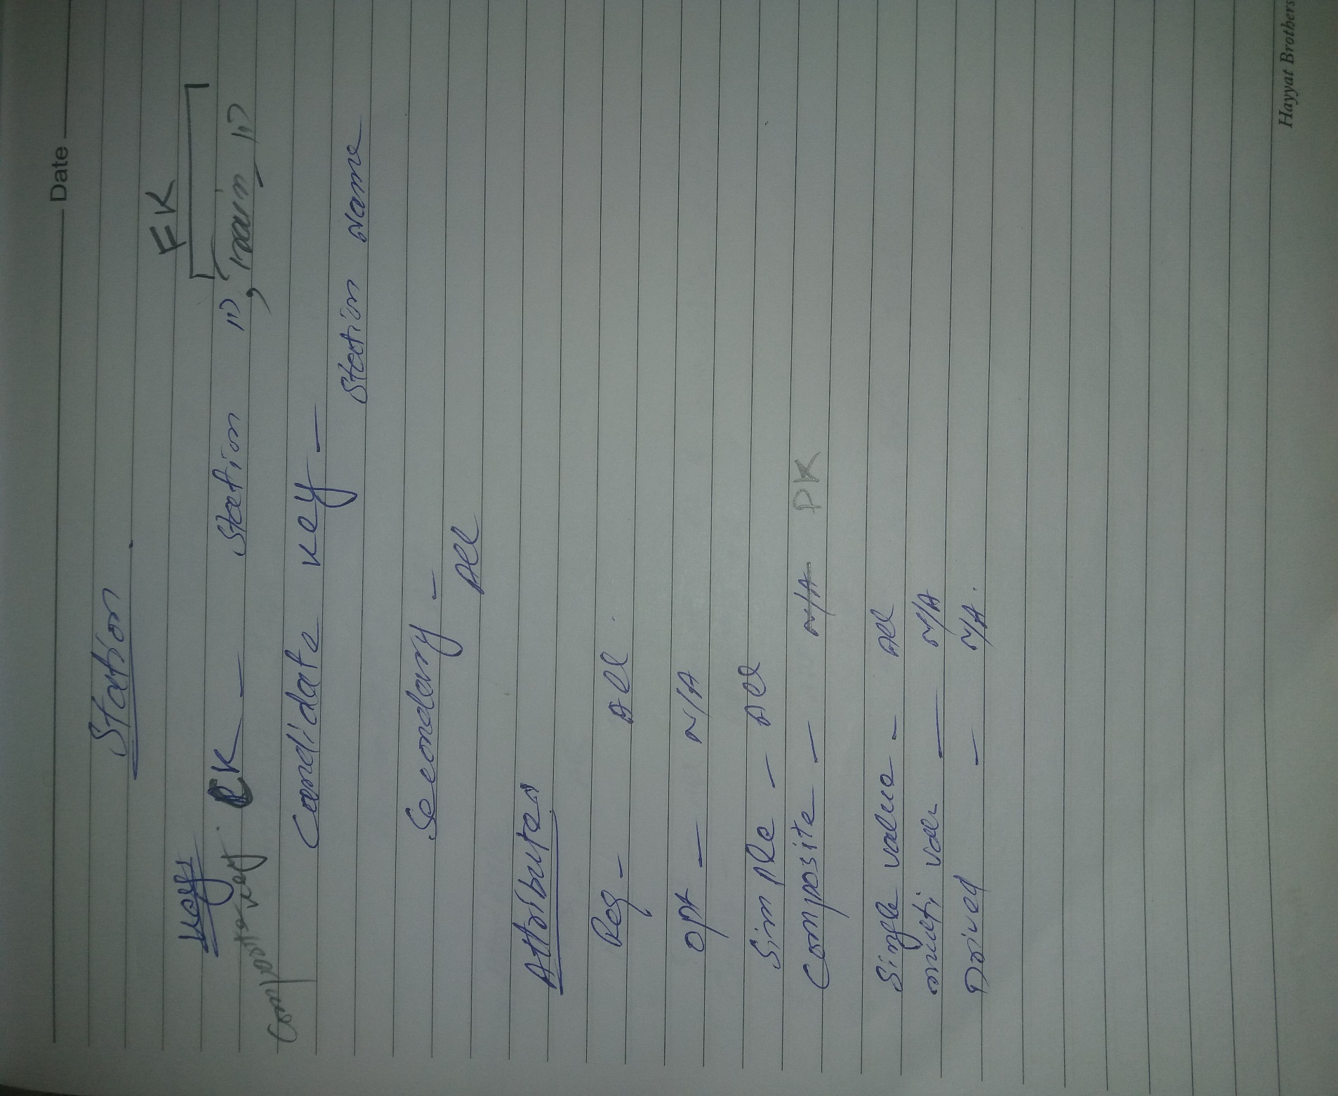

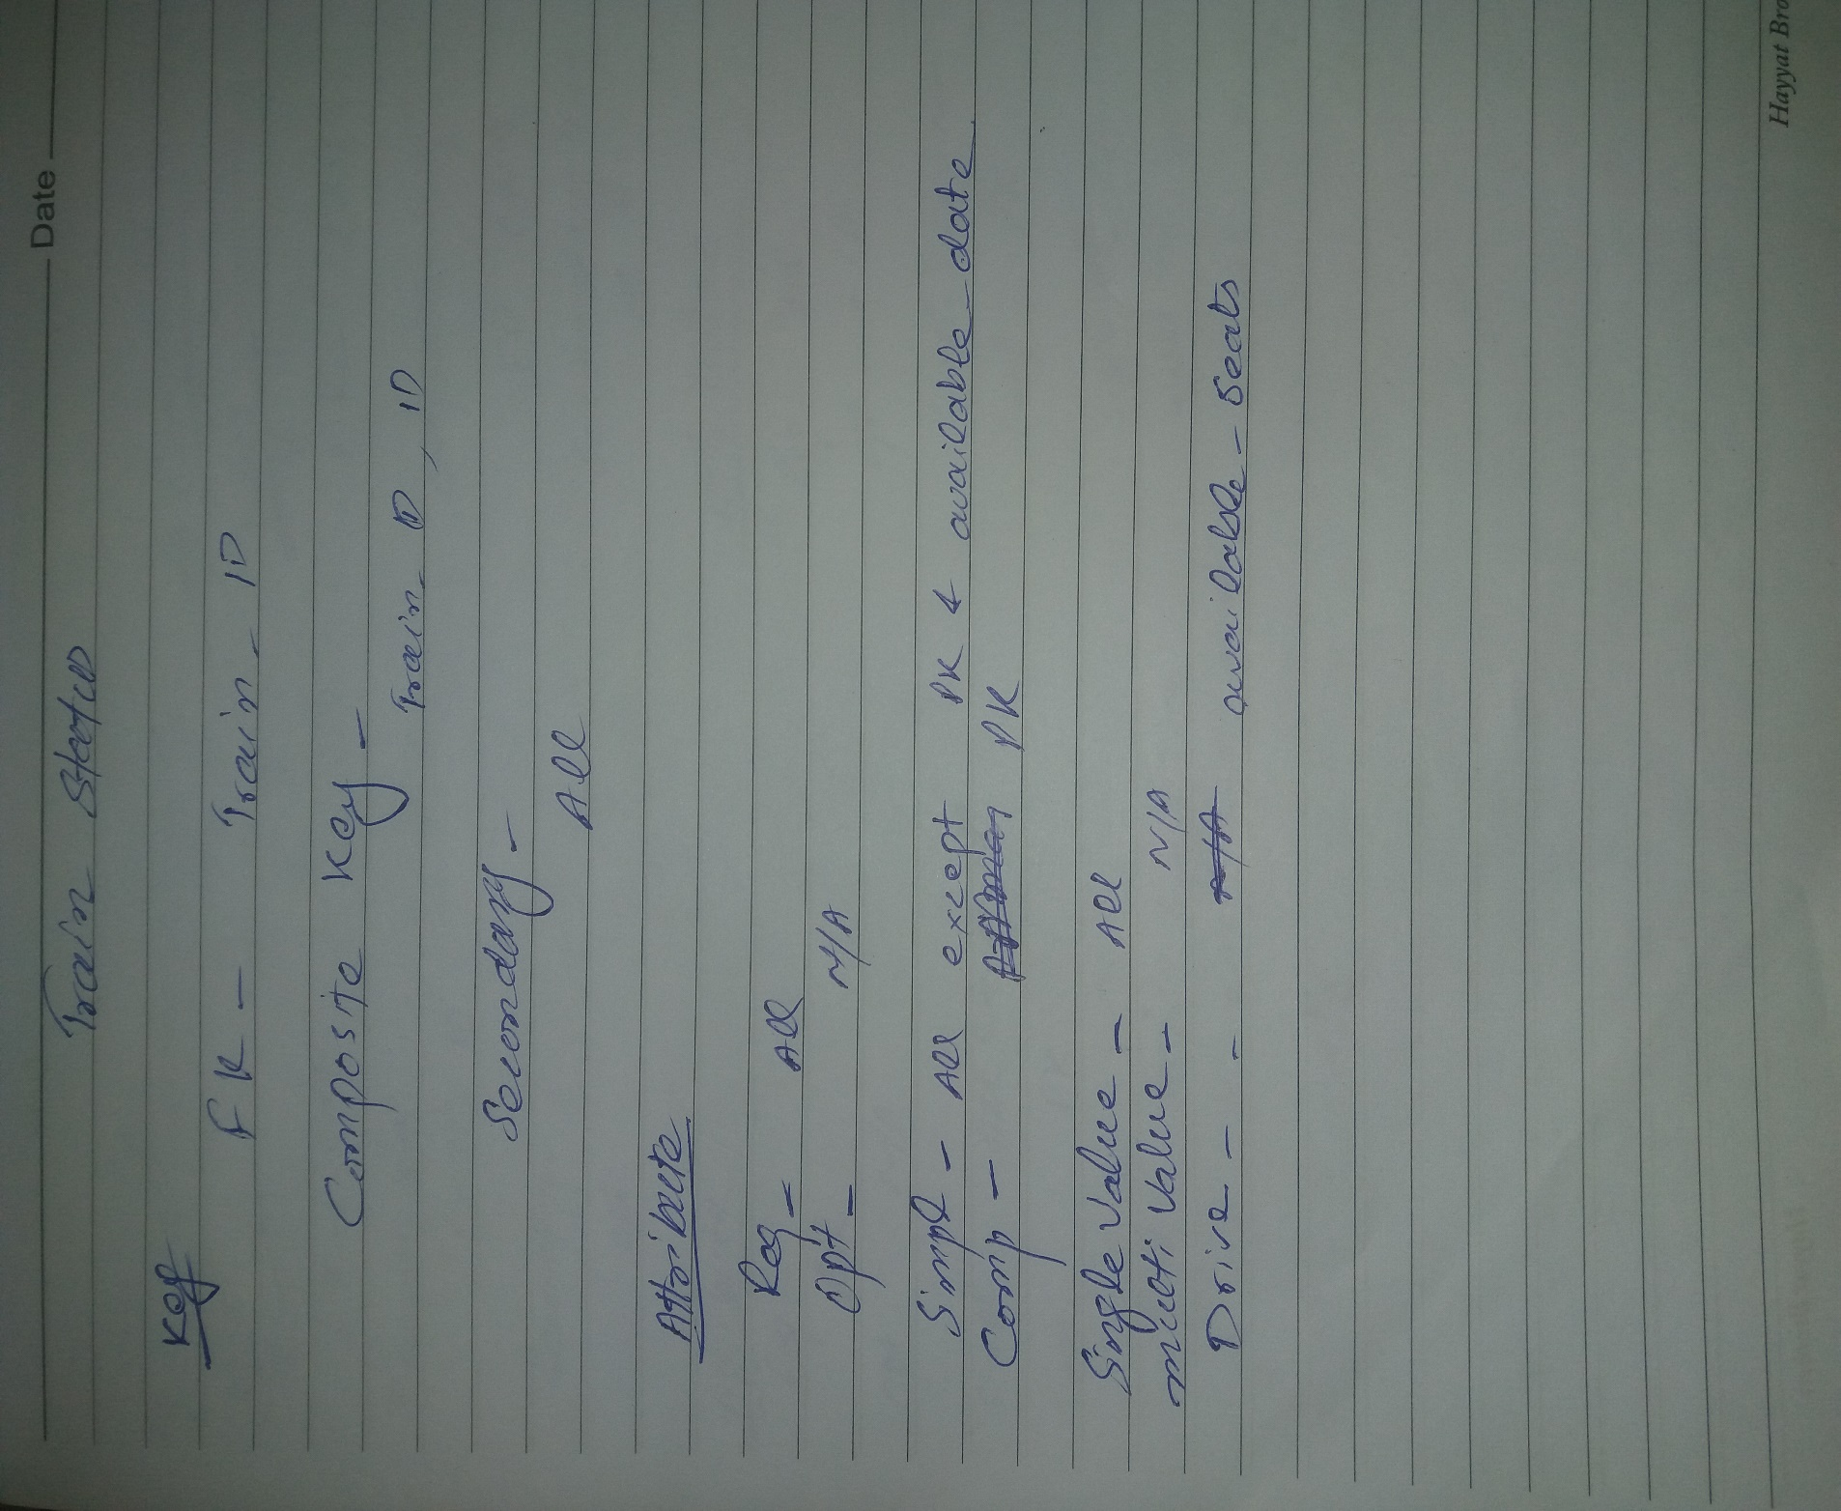

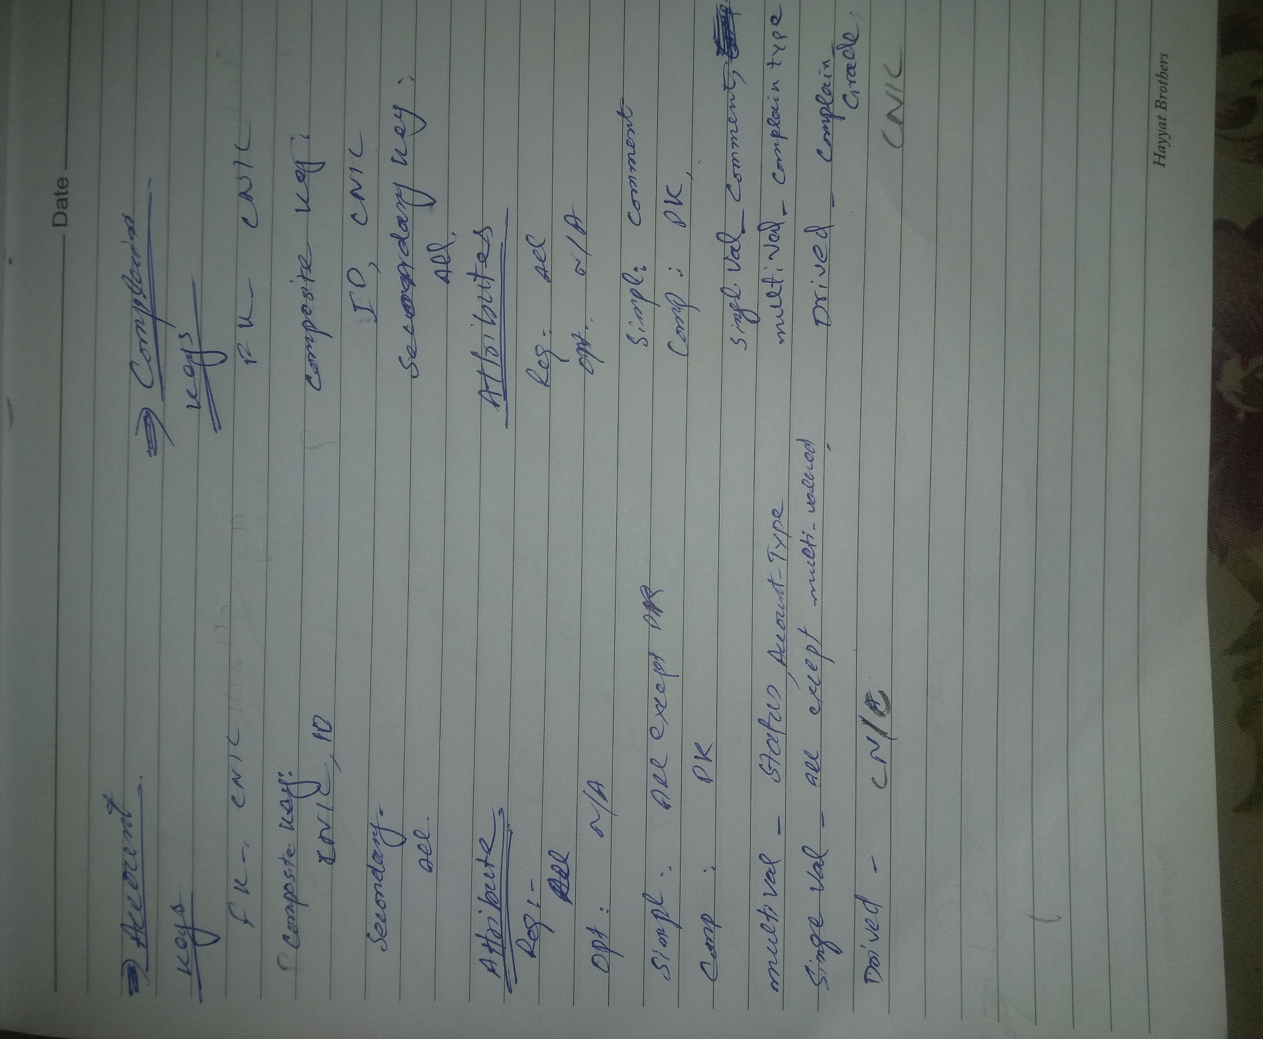

## **Chart of week 1**

# Week 2:

## **Slides**

**ONLINE RAILWAY**

**RESERVATION SYSTEM**

**Group Members:**

* 2015-CS-17 Ali Adnan Aslam
* 2015-CS-54 Muhammad Ramzan
* 2015-CS-64 Malik M Mursaleen

***Subject:***

Database Management System

***Supervisor:***

Dr. Khaldoon Khurshid.

**Overview:**

* Chen Model, Crow’s Foot Model
* ERM Models
* Relationship List
* Connectivity and Cardinality
* Existence Dependence
* ERM Diagram
* References

## **Chen Model**

* Entity is shown using rectangular
* PM key is underlined
* Attributes are shown using oval form
* Relationships are shown using Diamond shape

## **Crow’s Foot Model**

* Entity is shown using rectangular
* PM key is underlined
* Attributes are shown below the entity

## **Difference(cont’d)**

* Attributes Representation
* Multi Valued Attributes
* Required Attributes
* Derived Attributes

**Note:** Chen Model space consuming so, Crow’s Foot Model is Preferred

**Relationship List**

|  |  |  |
| --- | --- | --- |
| Sr.No | Relation Type | **Entity type** |
| 1 | Enquires | User, Train |
| 2 | Consists of | Station, Route |
| 3 | Has | Train, Train_Status |
| 4 | Checks | User, Train_Status |
| 5 | Has | Train, Route |
| 6 | Start From/Ends At | Train, Station |
| 7 | Manages | Admin, User/Passenger |
| 8 | Has | User/Passenger, Account |
| 9 | Submit | User/Passenger, Complain |

**USER, TRAIN**

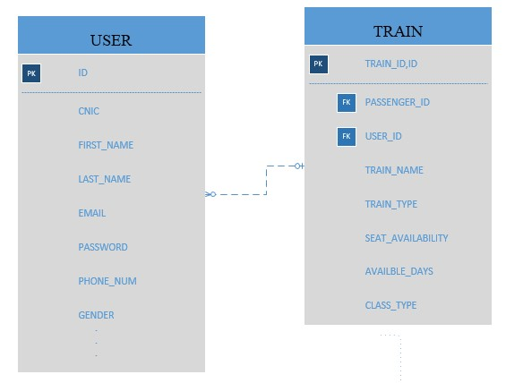

(

N,

1)

(1

,N

)

**PASSENGER, TRAIN**

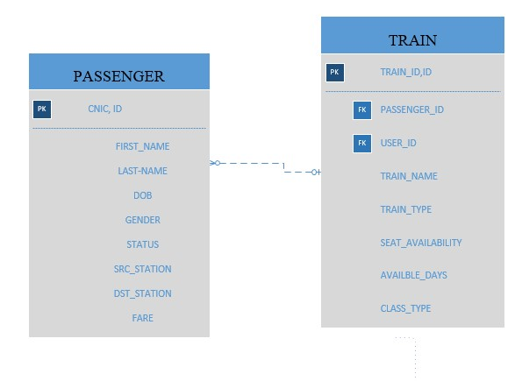

(

N,

1)

(1

,N

)

**USER, ACCOUNT**

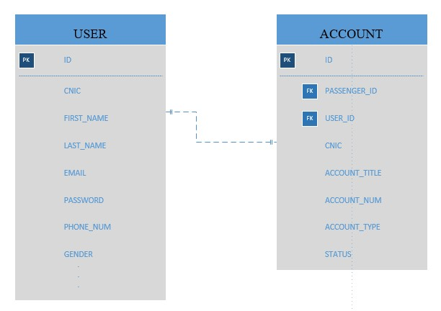

(1

,

1)

(1

,

1)

**PASSENGER, ACCOUNT**

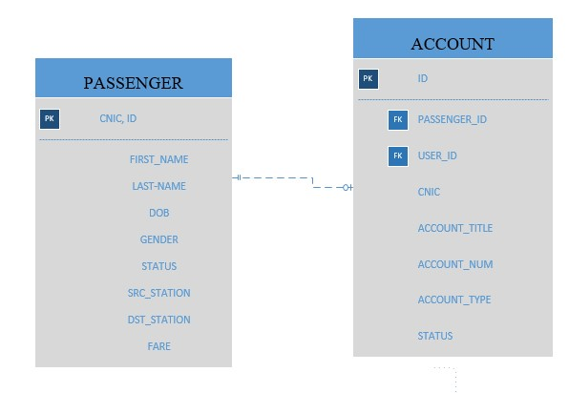

(1

,

1)

(0

,

1)

**USER, COMPLAIN**

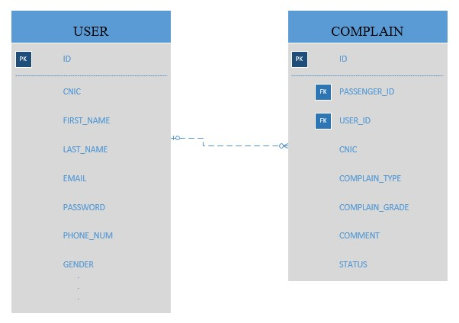

(1

,N

)

(

N,

1)

**PASSENGER, COMPLAIN**

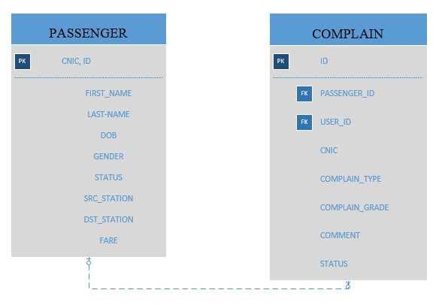

(1

,N

)

(

N,

1)

**TRAIN, STATION**

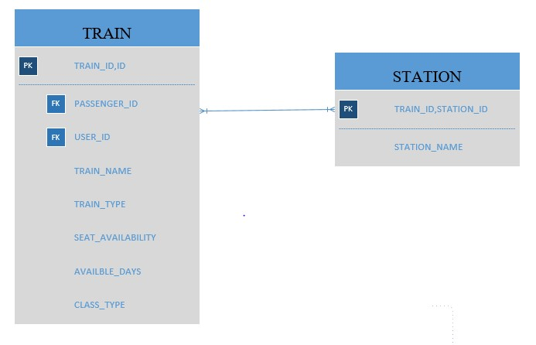

(1

,N

)

(

N,

1)

**TRAIN, ROUTE**

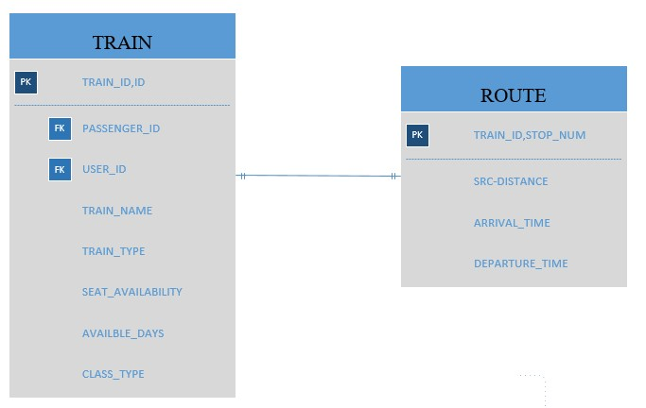

(1

,

1)

(1

,

1)

**TRAIN, TRAIN_STATUS**

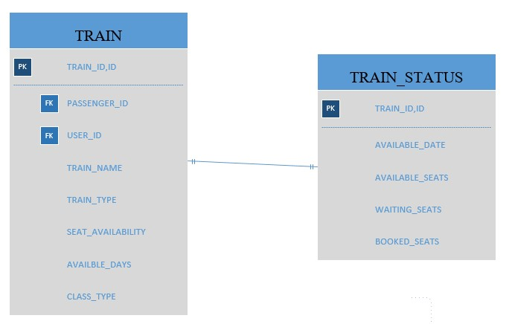

(1

,

1)

(1

,

1)

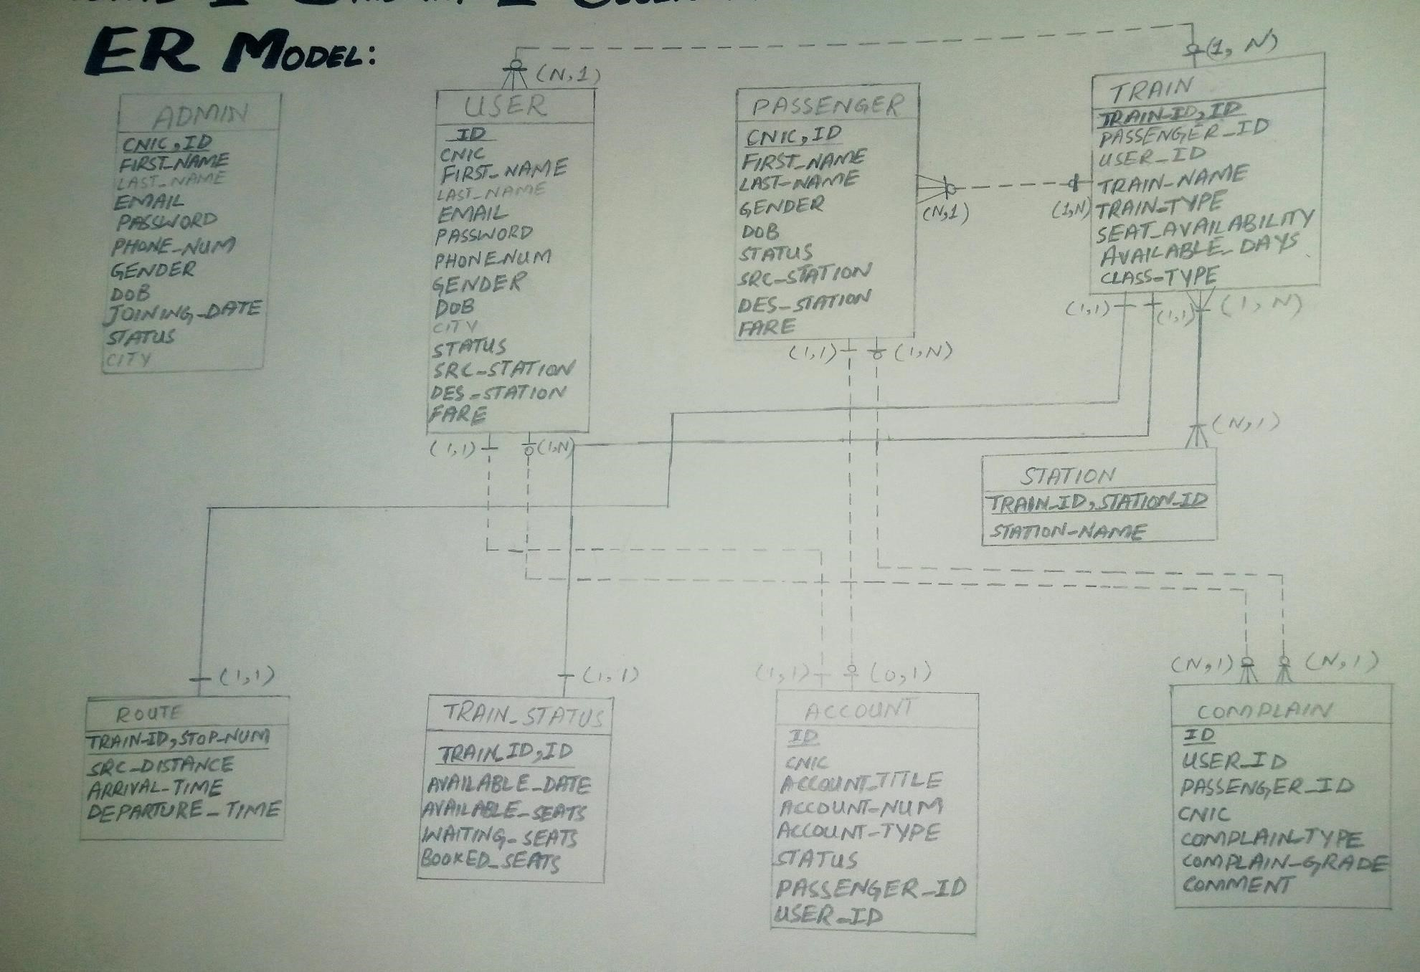**ER MODEL**

**Existence Dependence**

* Route

Train dependent also sharing Train_ID

* Station

Train dependent also sharing Train_ID

* Train_Status

Train dependent also sharing Train_ID

Reference:

Class Lectures Date: 3, April, 2018 WEEK #10-11

**References**

* <https://www.pakrail.gov.pk/SeatAvailability.aspx>
* [https://www.slideshare.net/masterpiyush/online-railwayreservation-system-33260680](https://www.slideshare.net/masterpiyush/online-railway-reservation-system-33260680)
* [https://www.google.com](https://www.google.com/)

## **Notebook**

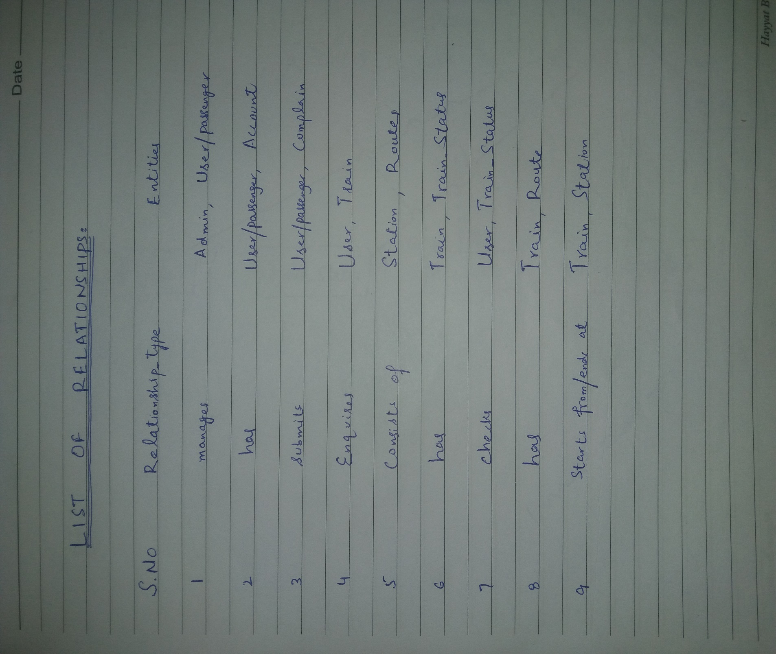

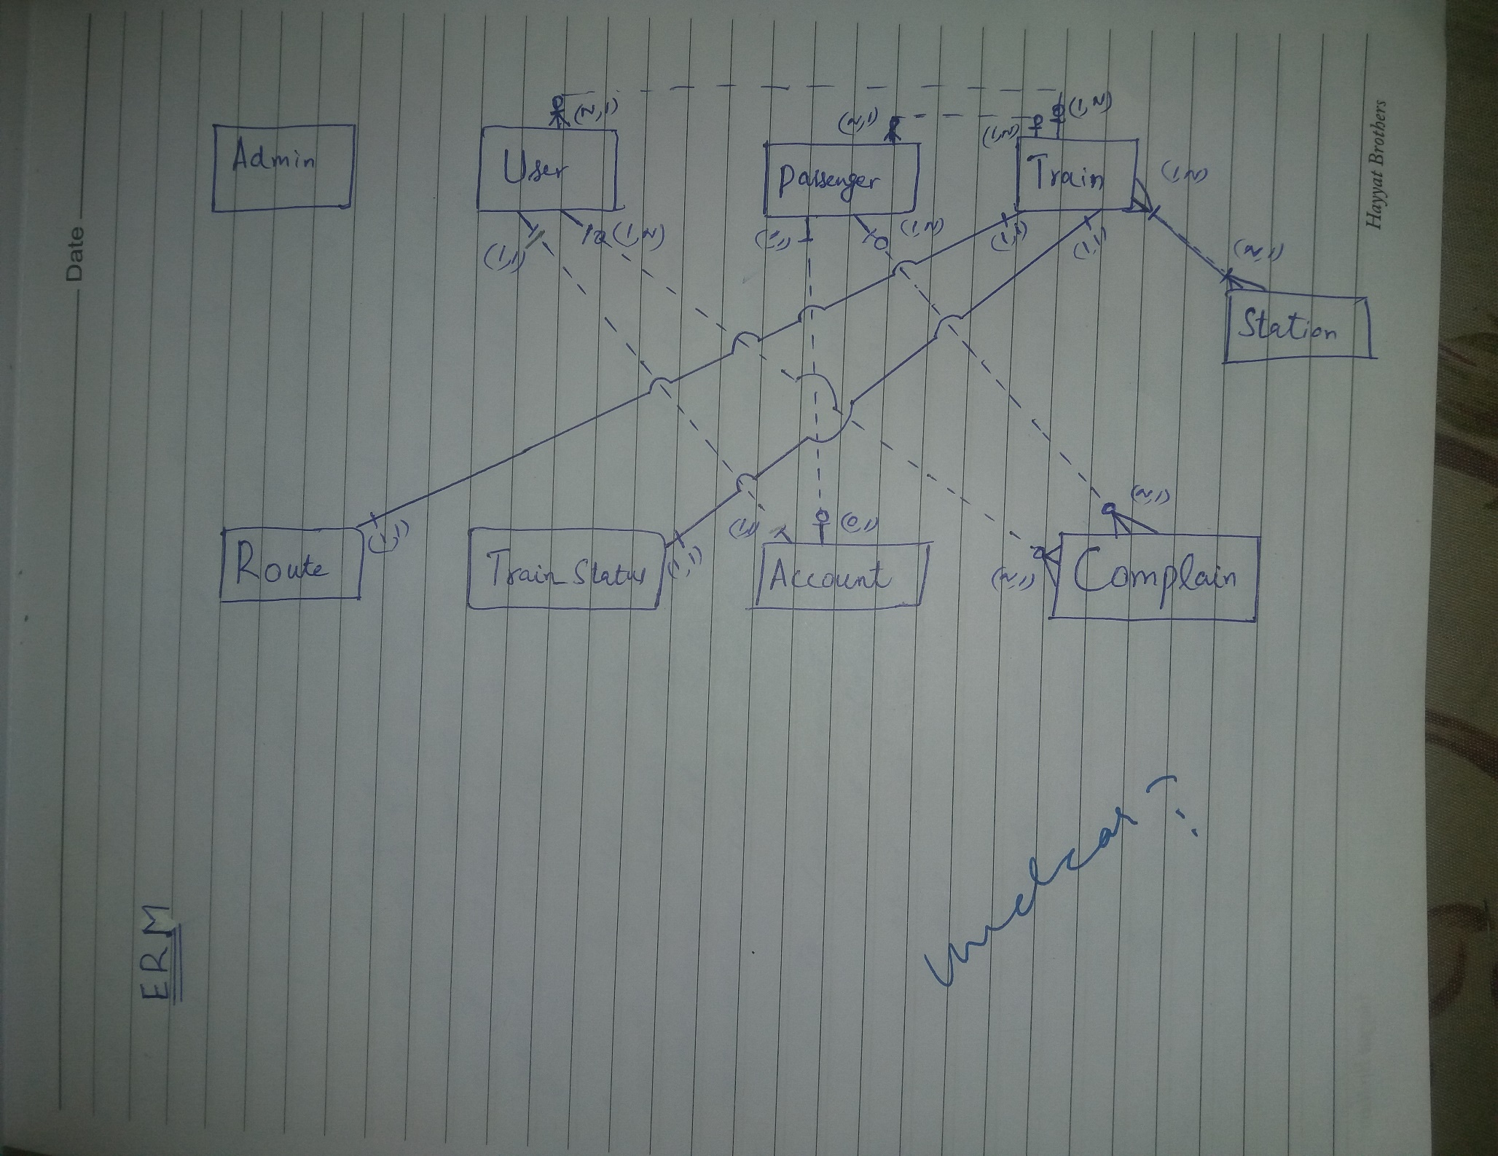

## **Chart of Week 2**

# Week 3:

## **Slides**

**ONLINE RAILWAY**

**RESERVATION SYSTEM**

**Group Members:**

* 2015-CS-17 Ali Adnan Aslam
* 2015-CS-54 Muhammad Ramzan
* 2015-CS-64 Malik M Mursaleen

***Subject:***

Database Management System

***Supervisor:***

Dr. Khaldoon Khurshid.

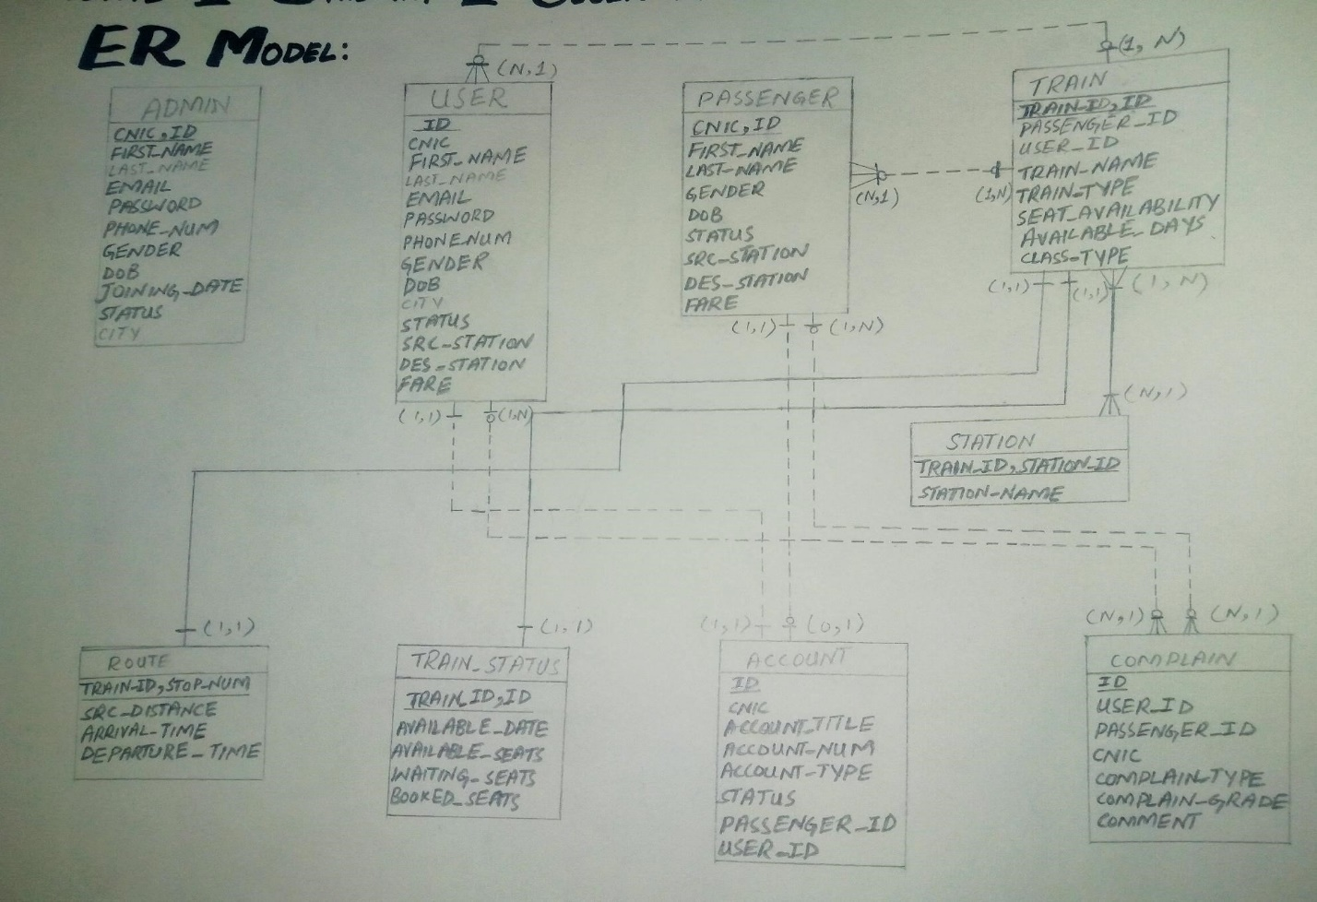**BEFORE NORMALIZATION**

**AFTER NORMALIZATION**

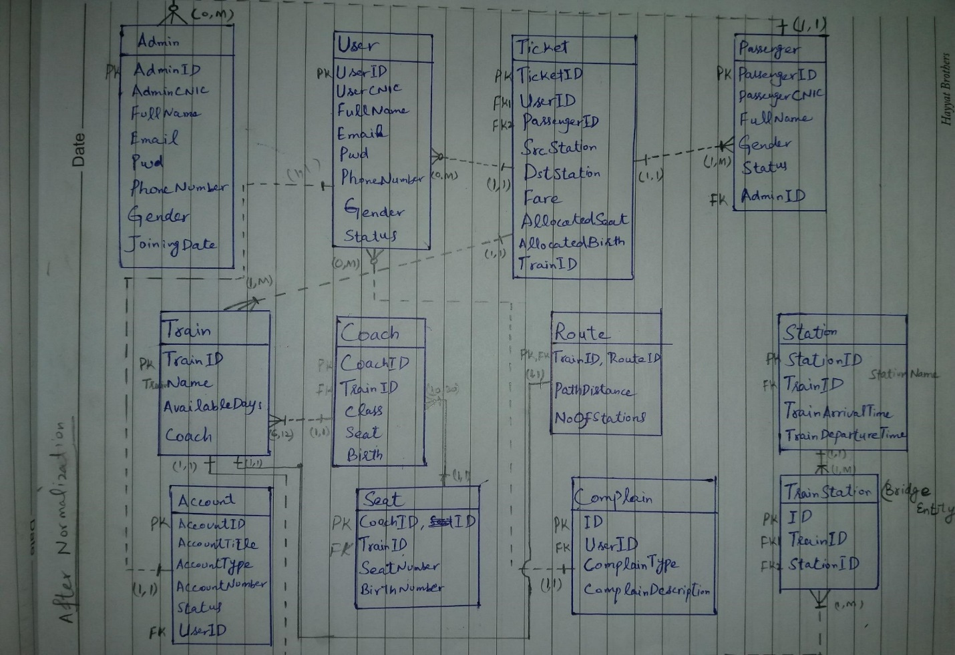

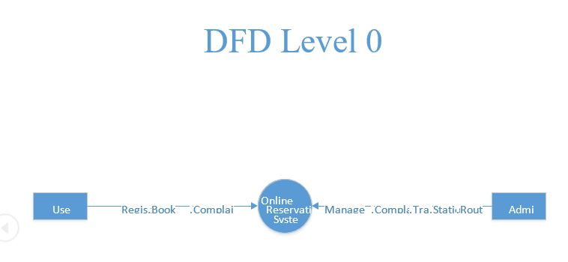**DATA FLOW DIAGRAM**

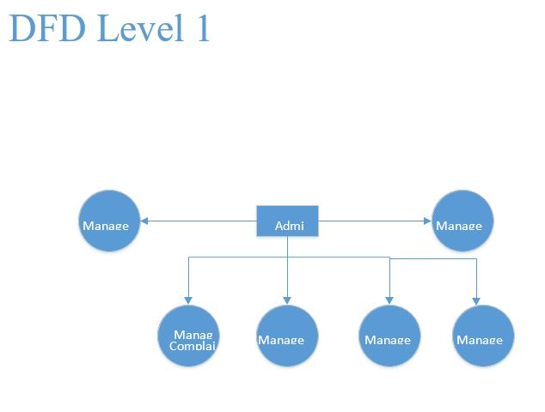

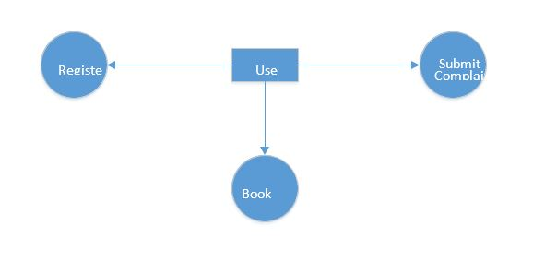

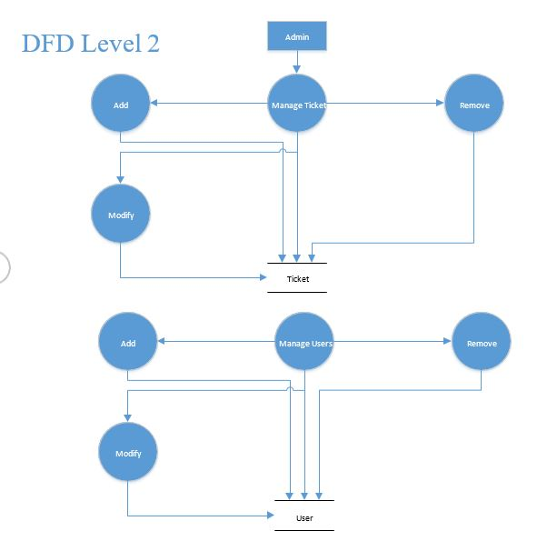

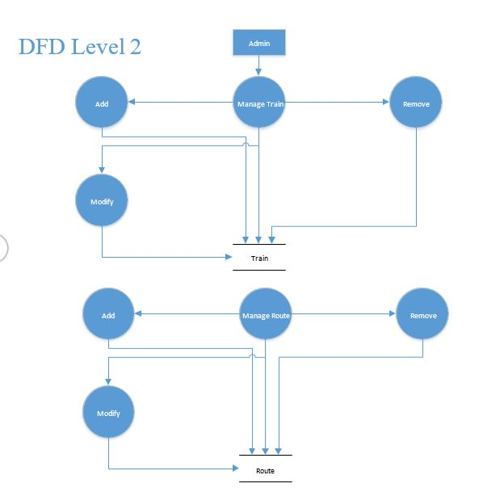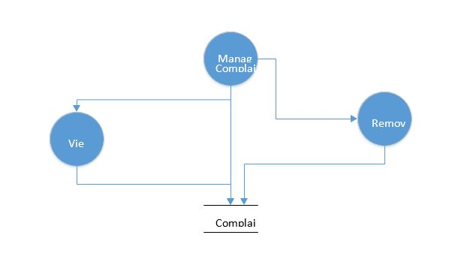

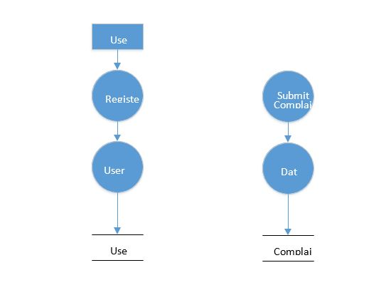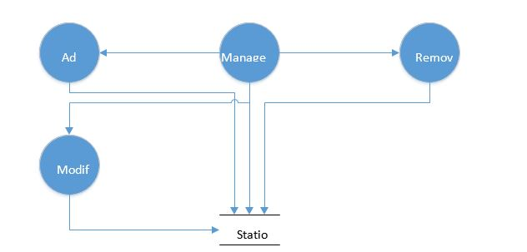DFD Level 2

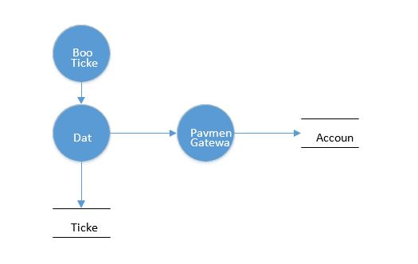

## **Notebook**

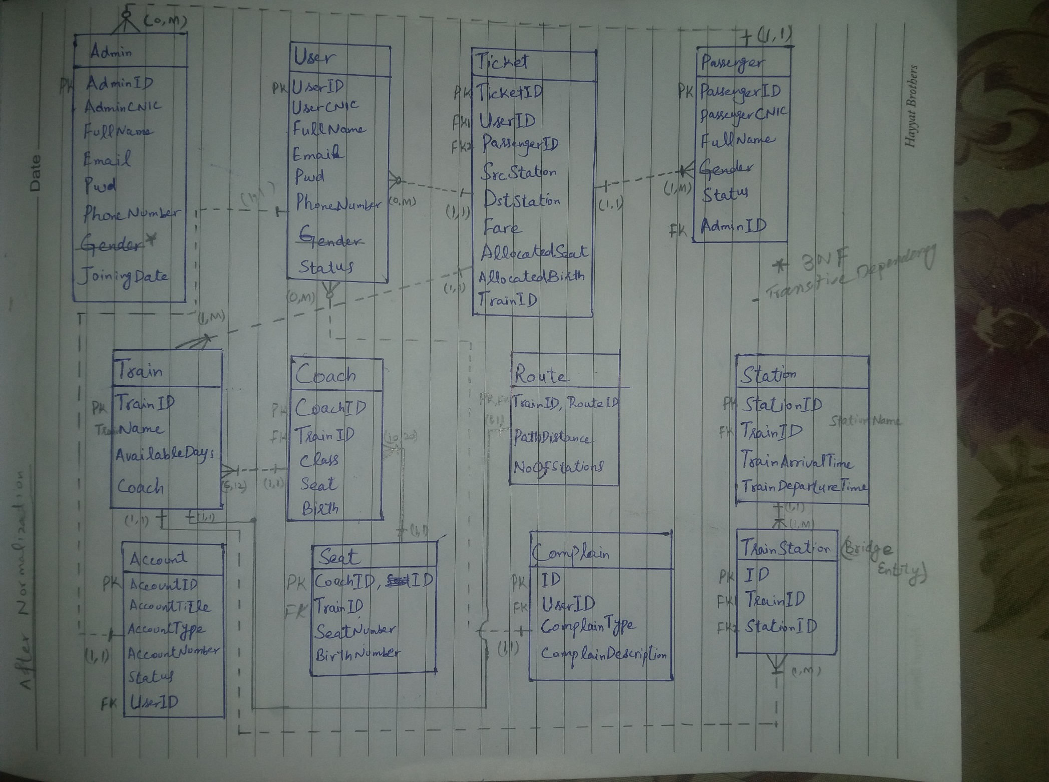

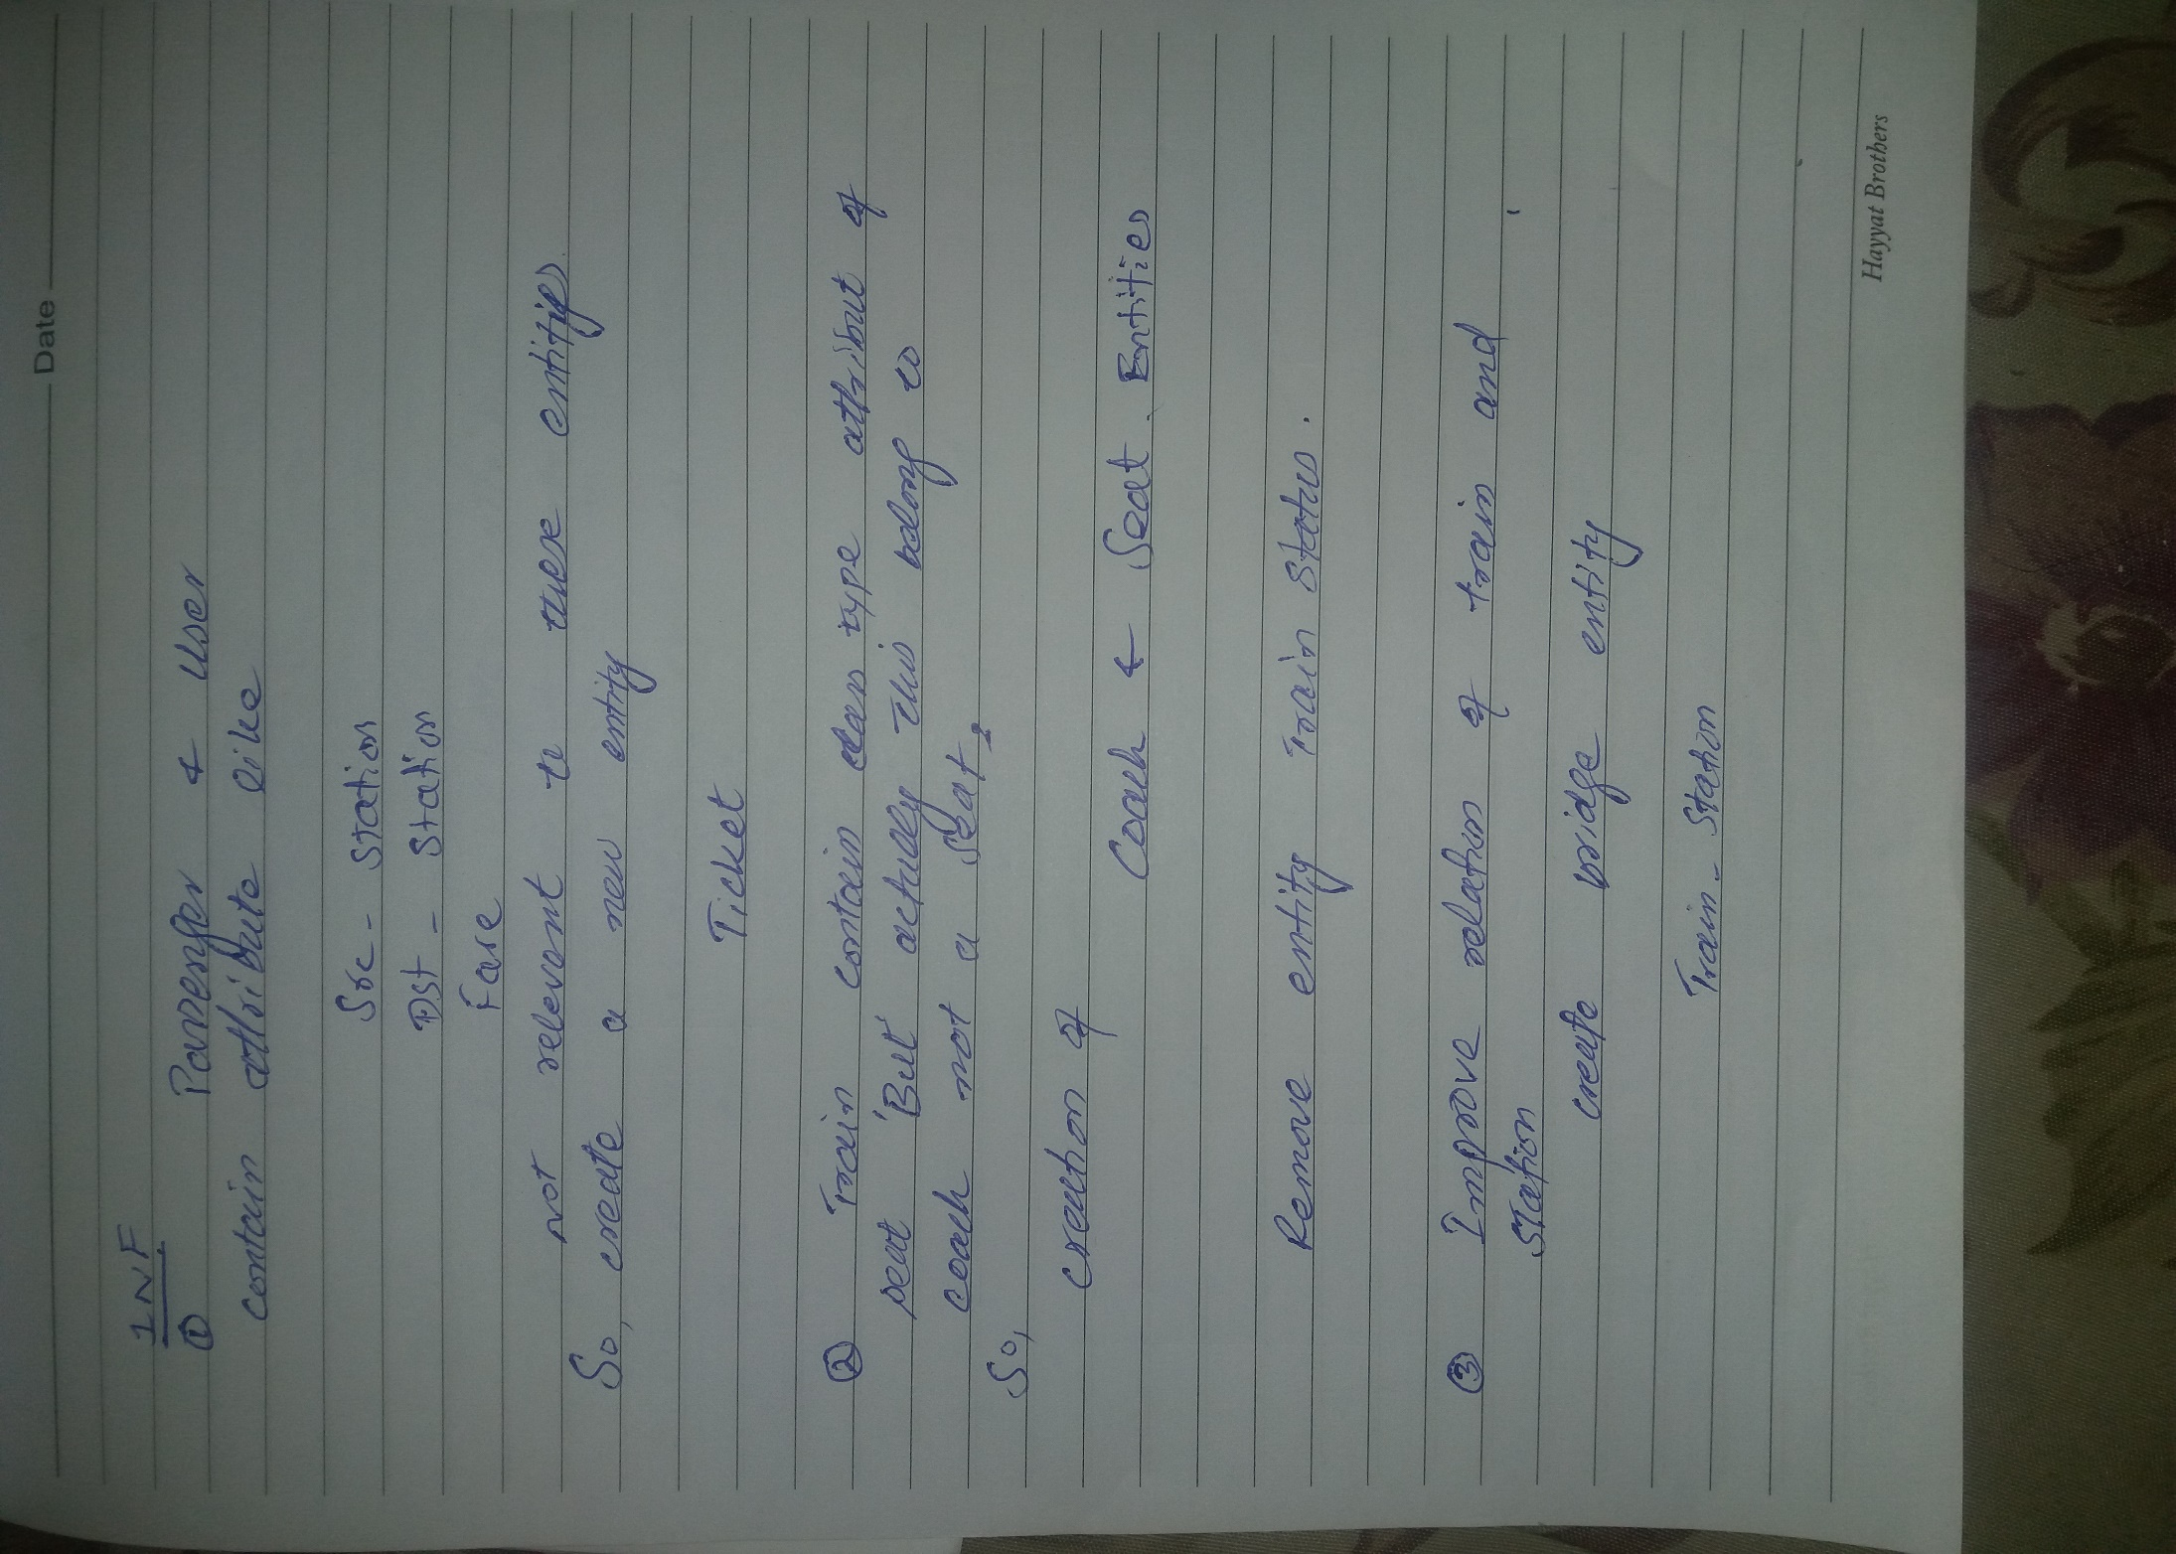

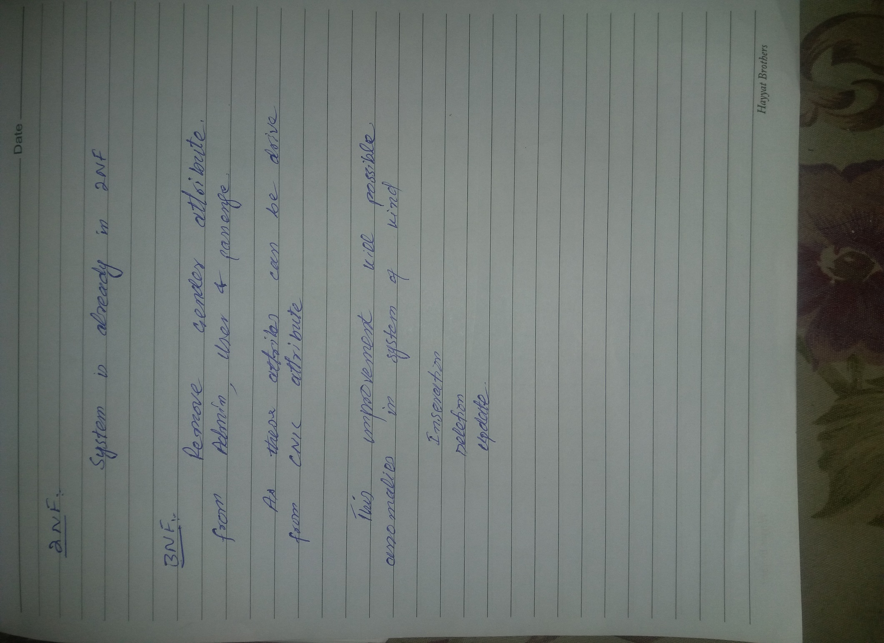

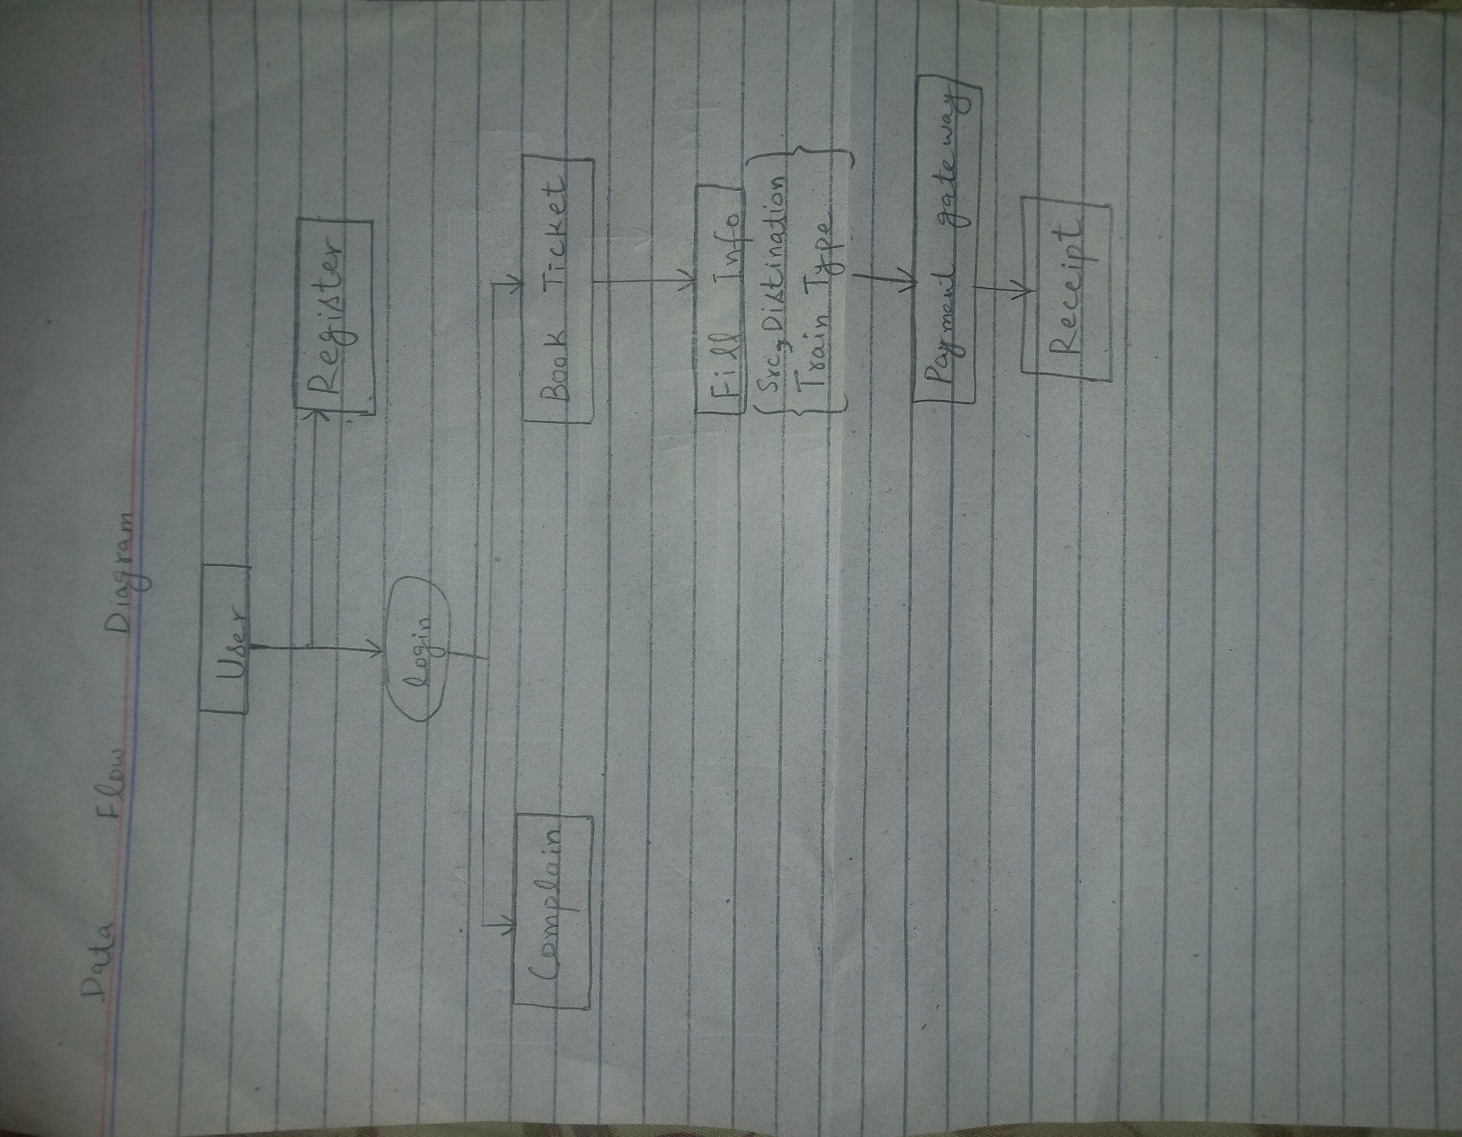

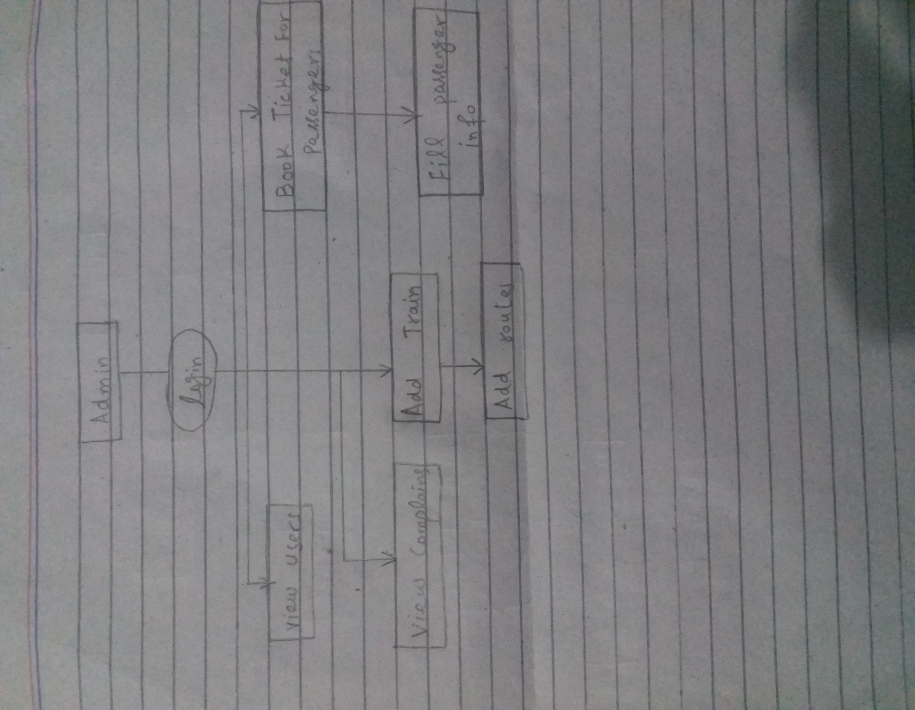

## **Chart of Week 3**

# DBMS Prototype Code:

We have implemented the prototype for our project using **MVC Database First approach on ASP.NET.** The basic operations of Database are as follows.

* Create
* Read
* Update
* Delete

Also known as CRUD operations.

These operations are same for all entities involve in our design concerning the implementation point. So, we including the code of Model (Entity), Controller and CRUD operations for AdminUser entity which is shown below.

## **AdminUser Model Code**

namespace OnlineRailwayReservationSystem.Models

{

using System;

using System.Data.Entity;

using System.Data.Entity.Infrastructure;

public partial class Online_Railway_Reservation_SystemEntities : DbContext

{

public Online_Railway_Reservation_SystemEntities()

: base("name=Online_Railway_Reservation_SystemEntities")

{

}

protected override void OnModelCreating(DbModelBuilder modelBuilder)

{

throw new UnintentionalCodeFirstException();

}

public virtual DbSet<Account> Accounts { get; set; }

public virtual DbSet<AdminUser> AdminUsers { get; set; }

public virtual DbSet<Coach> Coaches { get; set; }

public virtual DbSet<Complain> Complains { get; set; }

public virtual DbSet<Passenger> Passengers { get; set; }

public virtual DbSet<Route> Routes { get; set; }

public virtual DbSet<Seat> Seats { get; set; }

public virtual DbSet<Station> Stations { get; set; }

public virtual DbSet<sysdiagram> sysdiagrams { get; set; }

public virtual DbSet<Ticket> Tickets { get; set; }

public virtual DbSet<Train> Trains { get; set; }

public virtual DbSet<TrainStation> TrainStations { get; set; }

}}

## **AdminUser Controller Code**

using System;

using System.Collections.Generic;

using System.Data;

using System.Data.Entity;

using System.Linq;

using System.Net;

using System.Web;

using System.Web.Mvc;

using OnlineRailwayReservationSystem.Models;

namespace OnlineRailwayReservationSystem.Controllers

{

public class AdminUsersController : Controller

{

private Online_Railway_Reservation_SystemEntities db = new Online_Railway_Reservation_SystemEntities();

// GET: AdminUsers

public ActionResult Index()

{

return View(db.AdminUsers.ToList());

}

// GET: AdminUsers/Details/5

public ActionResult Details(int? id)

{

if (id == null)

{

return new HttpStatusCodeResult(HttpStatusCode.BadRequest);

}

AdminUser adminUser = db.AdminUsers.Find(id);

if (adminUser == null)

{

return HttpNotFound();

}

return View(adminUser);

}

// GET: AdminUsers/Create

public ActionResult Create()

{

return View();

}

// POST: AdminUsers/Create

// To protect from overposting attacks, please enable the specific properties you want to bind to, for

// more details see http://go.microsoft.com/fwlink/?LinkId=317598.

[HttpPost]

[ValidateAntiForgeryToken]

public ActionResult Create([Bind(Include = "UserID,UserCNIC,FullName,Email,PWD,PhoneNumber,Role")] AdminUser adminUser)

{

if (ModelState.IsValid)

{

db.AdminUsers.Add(adminUser);

db.SaveChanges();

return RedirectToAction("Index");

}

return View(adminUser);

}

// GET: AdminUsers/Edit/5

public ActionResult Edit(int? id)

{

if (id == null)

{

return new HttpStatusCodeResult(HttpStatusCode.BadRequest);

}

AdminUser adminUser = db.AdminUsers.Find(id);

if (adminUser == null)

{

return HttpNotFound();

}

return View(adminUser);

}

// POST: AdminUsers/Edit/5

// To protect from overposting attacks, please enable the specific properties you want to bind to, for

// more details see http://go.microsoft.com/fwlink/?LinkId=317598.

[HttpPost]

[ValidateAntiForgeryToken]

public ActionResult Edit([Bind(Include = "UserID,UserCNIC,FullName,Email,PWD,PhoneNumber,Role")] AdminUser adminUser)

{

if (ModelState.IsValid)

{

db.Entry(adminUser).State = EntityState.Modified;

db.SaveChanges();

return RedirectToAction("Index");

}

return View(adminUser);

}

// GET: AdminUsers/Delete/5

public ActionResult Delete(int? id)

{

if (id == null)

{

return new HttpStatusCodeResult(HttpStatusCode.BadRequest);

}

AdminUser adminUser = db.AdminUsers.Find(id);

if (adminUser == null)

{

return HttpNotFound();

}

return View(adminUser);

}

// POST: AdminUsers/Delete/5

[HttpPost, ActionName("Delete")]

[ValidateAntiForgeryToken]

public ActionResult DeleteConfirmed(int id)

{

AdminUser adminUser = db.AdminUsers.Find(id);

db.AdminUsers.Remove(adminUser);

db.SaveChanges();

return RedirectToAction("Index");

}

protected override void Dispose(bool disposing)

{

if (disposing)

{

db.Dispose();

}

base.Dispose(disposing);

}

}

}

## **AdminUser Views Code**

## **Create AdminUser**

@model OnlineRailwayReservationSystem.Models.AdminUser

@{

ViewBag.Title = "Create";

}

<h2>Create</h2>

@using (Html.BeginForm())

{

@Html.AntiForgeryToken()

<div class="form-horizontal">

<h4>AdminUser</h4>

<hr />

@Html.ValidationSummary(true, "", new { @class = "text-danger" })

<div class="form-group">

@Html.LabelFor(model => model.UserCNIC, htmlAttributes: new { @class = "control-label col-md-2" })

<div class="col-md-10">

@Html.EditorFor(model => model.UserCNIC, new { htmlAttributes = new { @class = "form-control" } })

@Html.ValidationMessageFor(model => model.UserCNIC, "", new { @class = "text-danger" })

</div>

</div>

<div class="form-group">

@Html.LabelFor(model => model.FullName, htmlAttributes: new { @class = "control-label col-md-2" })

<div class="col-md-10">

@Html.EditorFor(model => model.FullName, new { htmlAttributes = new { @class = "form-control" } })

@Html.ValidationMessageFor(model => model.FullName, "", new { @class = "text-danger" })

</div>

</div>

<div class="form-group">

@Html.LabelFor(model => model.Email, htmlAttributes: new { @class = "control-label col-md-2" })

<div class="col-md-10">

@Html.EditorFor(model => model.Email, new { htmlAttributes = new { @class = "form-control" } })

@Html.ValidationMessageFor(model => model.Email, "", new { @class = "text-danger" })

</div>

</div>

<div class="form-group">

@Html.LabelFor(model => model.PWD, htmlAttributes: new { @class = "control-label col-md-2" })

<div class="col-md-10">

@Html.EditorFor(model => model.PWD, new { htmlAttributes = new { @class = "form-control" } })

@Html.ValidationMessageFor(model => model.PWD, "", new { @class = "text-danger" })

</div>

</div>

<div class="form-group">

@Html.LabelFor(model => model.PhoneNumber, htmlAttributes: new { @class = "control-label col-md-2" })

<div class="col-md-10">

@Html.EditorFor(model => model.PhoneNumber, new { htmlAttributes = new { @class = "form-control" } })

@Html.ValidationMessageFor(model => model.PhoneNumber, "", new { @class = "text-danger" })

</div>

</div>

<div class="form-group">

@Html.LabelFor(model => model.Role, htmlAttributes: new { @class = "control-label col-md-2" })

<div class="col-md-10">

@Html.EditorFor(model => model.Role, new { htmlAttributes = new { @class = "form-control" } })

@Html.ValidationMessageFor(model => model.Role, "", new { @class = "text-danger" })

</div>

</div>

<div class="form-group">

<div class="col-md-offset-2 col-md-10">

<input type="submit" value="Create" class="btn btn-default" />

</div>

</div>

</div>

}

<div>

@Html.ActionLink("Back to List", "Index")

</div>

@section Scripts {

@Scripts.Render("~/bundles/jqueryval")

}

### **Read AdminUser**

@model IEnumerable<OnlineRailwayReservationSystem.Models.AdminUser>

@{

ViewBag.Title = "Index";

}

<h2>Index</h2>

<p>

@Html.ActionLink("Create New", "Create")

</p>

<table class="table">

<tr>

<th>

@Html.DisplayNameFor(model => model.UserCNIC)

</th>

<th>

@Html.DisplayNameFor(model => model.FullName)

</th>

<th>

@Html.DisplayNameFor(model => model.Email)

</th>

<th>

@Html.DisplayNameFor(model => model.PWD)

</th>

<th>

@Html.DisplayNameFor(model => model.PhoneNumber)

</th>

<th>

@Html.DisplayNameFor(model => model.Role)

</th>

<th></th>

</tr>

@foreach (var item in Model) {

<tr>

<td>

@Html.DisplayFor(modelItem => item.UserCNIC)

</td>

<td>

@Html.DisplayFor(modelItem => item.FullName)

</td>

<td>

@Html.DisplayFor(modelItem => item.Email)

</td>

<td>

@Html.DisplayFor(modelItem => item.PWD)

</td>

<td>

@Html.DisplayFor(modelItem => item.PhoneNumber)

</td>

<td>

@Html.DisplayFor(modelItem => item.Role)

</td>

<td>

@Html.ActionLink("Edit", "Edit", new { id=item.UserID }) |

@Html.ActionLink("Details", "Details", new { id=item.UserID }) |

@Html.ActionLink("Delete", "Delete", new { id=item.UserID })

</td>

</tr>

}

</table>

### **Update AdminUser**

@model OnlineRailwayReservationSystem.Models.AdminUser

@{

ViewBag.Title = "Edit";

}

<h2>Edit</h2>

@using (Html.BeginForm())

{

@Html.AntiForgeryToken()

<div class="form-horizontal">

<h4>AdminUser</h4>

<hr />

@Html.ValidationSummary(true, "", new { @class = "text-danger" })

@Html.HiddenFor(model => model.UserID)

<div class="form-group">

@Html.LabelFor(model => model.UserCNIC, htmlAttributes: new { @class = "control-label col-md-2" })

<div class="col-md-10">

@Html.EditorFor(model => model.UserCNIC, new { htmlAttributes = new { @class = "form-control" } })

@Html.ValidationMessageFor(model => model.UserCNIC, "", new { @class = "text-danger" })

</div>

</div>

<div class="form-group">

@Html.LabelFor(model => model.FullName, htmlAttributes: new { @class = "control-label col-md-2" })

<div class="col-md-10">

@Html.EditorFor(model => model.FullName, new { htmlAttributes = new { @class = "form-control" } })

@Html.ValidationMessageFor(model => model.FullName, "", new { @class = "text-danger" })

</div>

</div>

<div class="form-group">

@Html.LabelFor(model => model.Email, htmlAttributes: new { @class = "control-label col-md-2" })

<div class="col-md-10">

@Html.EditorFor(model => model.Email, new { htmlAttributes = new { @class = "form-control" } })

@Html.ValidationMessageFor(model => model.Email, "", new { @class = "text-danger" })

</div>

</div>

<div class="form-group">

@Html.LabelFor(model => model.PWD, htmlAttributes: new { @class = "control-label col-md-2" })

<div class="col-md-10">

@Html.EditorFor(model => model.PWD, new { htmlAttributes = new { @class = "form-control" } })

@Html.ValidationMessageFor(model => model.PWD, "", new { @class = "text-danger" })

</div>

</div>

<div class="form-group">

@Html.LabelFor(model => model.PhoneNumber, htmlAttributes: new { @class = "control-label col-md-2" })

<div class="col-md-10">

@Html.EditorFor(model => model.PhoneNumber, new { htmlAttributes = new { @class = "form-control" } })

@Html.ValidationMessageFor(model => model.PhoneNumber, "", new { @class = "text-danger" })

</div>

</div>

<div class="form-group">

@Html.LabelFor(model => model.Role, htmlAttributes: new { @class = "control-label col-md-2" })

<div class="col-md-10">

@Html.EditorFor(model => model.Role, new { htmlAttributes = new { @class = "form-control" } })

@Html.ValidationMessageFor(model => model.Role, "", new { @class = "text-danger" })

</div>

</div>

<div class="form-group">

<div class="col-md-offset-2 col-md-10">

<input type="submit" value="Save" class="btn btn-default" />

</div>

</div>

</div>

}

<div>

@Html.ActionLink("Back to List", "Index")

</div>

@section Scripts {

@Scripts.Render("~/bundles/jqueryval")

}

### **Delete AdminUser**

@model OnlineRailwayReservationSystem.Models.AdminUser

@{

ViewBag.Title = "Delete";

}

<h2>Delete</h2>

<h3>Are you sure you want to delete this?</h3>

<div>

<h4>AdminUser</h4>

<hr />

<dl class="dl-horizontal">

<dt>

@Html.DisplayNameFor(model => model.UserCNIC)

</dt>

<dd>

@Html.DisplayFor(model => model.UserCNIC)

</dd>

<dt>

@Html.DisplayNameFor(model => model.FullName)

</dt>

<dd>

@Html.DisplayFor(model => model.FullName)

</dd>

<dt>

@Html.DisplayNameFor(model => model.Email)

</dt>

<dd>

@Html.DisplayFor(model => model.Email)

</dd>

<dt>

@Html.DisplayNameFor(model => model.PWD)

</dt>

<dd>

@Html.DisplayFor(model => model.PWD)

</dd>

<dt>

@Html.DisplayNameFor(model => model.PhoneNumber)

</dt>

<dd>

@Html.DisplayFor(model => model.PhoneNumber)

</dd>

<dt>

@Html.DisplayNameFor(model => model.Role)

</dt>

<dd>

@Html.DisplayFor(model => model.Role)

</dd>

</dl>

@using (Html.BeginForm()) {

@Html.AntiForgeryToken()

<div class="form-actions no-color">

<input type="submit" value="Delete" class="btn btn-default" /> |

@Html.ActionLink("Back to List", "Index")

</div>

}</div>

**Query Optimization:**

**Use [Online Railway Reservation System]**

**GO**

**CREATE TABLE AdminUser (**

**UserID int NOT NULL PRIMARY KEY IDENTITY(1, 1),**

**UserCNIC varchar(15) NOT NULL,**

**FullName varchar(30) NOT NULL,**

**Email varchar(20) NOT NULL,**

**PWD varchar(25) NOT NULL,**

**PhoneNumber varchar(15) NOT NULL,**

**Role char(1) NOT NULL,**

**);**

**CREATE TABLE Passenger (**

**PassengerID int NOT NULL PRIMARY KEY IDENTITY(1, 1),**

**PassengerCNIC varchar(15) NOT NULL,**

**FullName varchar(30) NOT NULL,**

**UserID int NOT NULL,**

**FOREIGN KEY (UserID) REFERENCES AdminUser(UserID)**

**);**

**CREATE TABLE Ticket (**

**TicketID int NOT NULL PRIMARY KEY IDENTITY(1, 1),**

**CustomerID int NOT NULL,**

**SrcStation varchar(30) NOT NULL,**

**DstStation varchar(30) NOT NULL,**

**Fare int NOT NULL,**

**AllocatedSeat int DEFAULT 0,**

**AllocatedBirth int DEFAULT 0,**

**TrainID int NOT NULL,**

**FOREIGN KEY (CustomerID) REFERENCES AdminUser(UserID),**

**FOREIGN KEY (CustomerID) REFERENCES Passenger(PassengerID),**

**FOREIGN KEY (TrainID) REFERENCES Train(TrainID),**

**);**

**CREATE TABLE Train (**

**TrainID int NOT NULL PRIMARY KEY IDENTITY(1, 1),**

**TrainName varchar(30) NOT NULL,**

**AvailableDay varchar(60),**

**TotalNumberOfCoach int NOT NULL**

**);**

**CREATE TABLE Station (**

**StationID int NOT NULL PRIMARY KEY IDENTITY(1, 1),**

**TrainID int NOT NULL,**

**StationName varchar(30) NOT NULL,**

**TrainArrivalTime Time,**

**TrainDepartureTime Time,**

**FOREIGN KEY (TrainID) REFERENCES Train(TrainID)**

**);**

**CREATE TABLE TrainStation (**

**ID int NOT NULL PRIMARY KEY IDENTITY(1, 1),**

**TrainID int NOT NULL,**

**StationID int NOT NULL,**

**FOREIGN KEY (TrainID) REFERENCES Train(TrainID),**

**FOREIGN KEY (StationID) REFERENCES Station(StationID),**

**);**

**CREATE TABLE Coach (**

**CoachID int NOT NULL IDENTITY(1, 1) PRIMARY KEY,**

**TrainID int NOT NULL,**

**Class varchar(20) NOT NULL,**

**TotalNumberOfSeat int NOT NULL,**

**TotalNumberOfBirth int NOT NULL,**

**FOREIGN KEY (TrainID) REFERENCES Train(TrainID)**

**);**

**CREATE TABLE Seat (**

**CoachID int NOT NULL,**

**ID int NOT NULL IDENTITY(1, 1),**

**PRIMARY KEY (CoachID, ID),**

**TrainID int NOT NULL,**

**SeatNumber int NOT NULL,**

**BirthNumber int NOT NULL,**

**FOREIGN KEY (CoachID) REFERENCES Coach(coachID),**

**FOREIGN KEY (TrainID) REFERENCES Train(TrainID),**

**);**

**CREATE TABLE Route (**

**TrainID int NOT NULL,**

**RouteID int NOT NULL,**

**PRIMARY KEY(TrainID, RouteID),**

**RouteSource varchar(30) NOT NULL,**

**RouteDestination varchar(30) NOT NULL,**

**TotalDistance float NOT NULL,**

**NumberOfStations int NOT NULL,**

**FOREIGN KEY (TrainID) REFERENCES Train(TrainID),**

**);**

**CREATE TABLE Complain (**

**ComplainID int NOT NULL PRIMARY KEY IDENTITY(1, 1),**

**UserID int NOT NULL,**

**ComplainType text,**

**ComplainDescription text,**

**FOREIGN KEY (UserID) REFERENCES AdminUser(UserID),**

**);**

**CREATE TABLE Account (**

**AccountID int NOT NULL PRIMARY KEY IDENTITY(1, 1),**

**AccountTitle varchar(30) NOT NULL,**

**AccountType varchar(20) NOT NULL,**

**Status char(1),**

**UserID int NOT NULL,**

**FOREIGN KEY (UserID) REFERENCES AdminUser(UserID),**

**);**